Layered salad
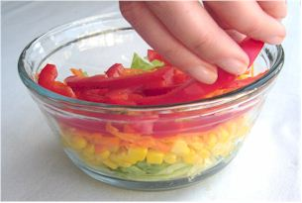
Ingredients
½ lettuce
Complexity: low-medium
1 carrot
1 red pepper
1 small can of sweetcorn

Equipment
Chopping board, knife, vegetable peeler, grater, can opener, colander, serving dish.

Method
- Prepare the vegetables:
  - wash the lettuce and shred;
  - top and tail the carrot, peel and grate;
  - deseed the red pepper and slice;
  - drain the sweetcorn.
- Arrange in layers in the serving dish.

Top tips
- Use a variety of different vegetables and fruit, e.g. red cabbage, apple, onion, new potatoes and beansprouts.
- Add a layer of boiled egg, canned tuna or grated cheese to make a main meal.

Food skills
- Shred.
- Trim and slice.
- Peel.
- Grate.
- Layer.

