Mixed vegetables
Ingredients
Complexity: low-medium
2 carrots
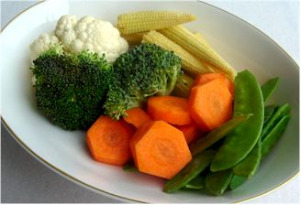
1 head broccoli
½ cauliflower
50g baby sweetcorn, optional
50g mange tout, optional

Equipment
Chopping board, vegetable peeler, knife, steamer or saucepan, colander, plate.

Method
- Wash all the vegetables.
- Peel and slice the carrots into rounds.
- Remove the green leaves and hard stalk from the broccoli and cauliflower and cut into florets.
- Place all the vegetables into a steamer or in a colander over a saucepan of boiling water with a plate over the top.
- Allow to steam for 10 minutes.

Top tips
- Vary the selection of vegetables to give a colourful mix at any time of the year.
- Use a mixture of fresh, frozen and canned vegetables for variety.
- Check out which vegetables are in season.

Food skills
- Weigh.
- Peel.
- Slice and cut.
- Steam or boil and simmer.
- Drain.

