Noodles
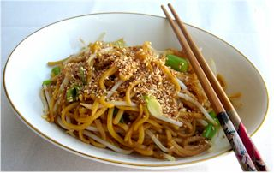
Ingredients
150g dried noodles
Complexity: low-medium
Spray oil
2 spring onions
50g beansprouts
1x15ml spoon reduced salt soy sauce/fish sauce
½ 5ml spoon sesame seeds (optional)

Equipment
Saucepan, colander, chopping board, knife, wok/large pan, measuring spoons, wooden spoon.

Method
- Cook the noodles as instructed on the packaging. Drain.
- Top and tail the spring onion and slice into rings.
- Heat the oil in wok/large pan.
- Add the noodles, onion and beansprouts.
- Stir-fry for 2-3 minutes.
- Add the soy/fish sauce.
- Serve – garnish with sesame seeds, if desired.

Top Tips
- You may wish to eat your noodles plain. If so, just cook as instructed on the packaging.
- Add extra vegetables to create a noodle main meal, e.g. frozen peas, canned sweetcorn, sliced mushrooms, chopped red pepper.
- You may wish to toast the sesame seeds.
- Note – some people may be allergic to sesame seeds. Always check before serving the dish to someone else.

Food skills
- Measure.
- Weigh.
- Boil and simmer.
- Trim and slice.
- Fry.
- Stir.

