Poached pears
Ingredients
Complexity: low-medium
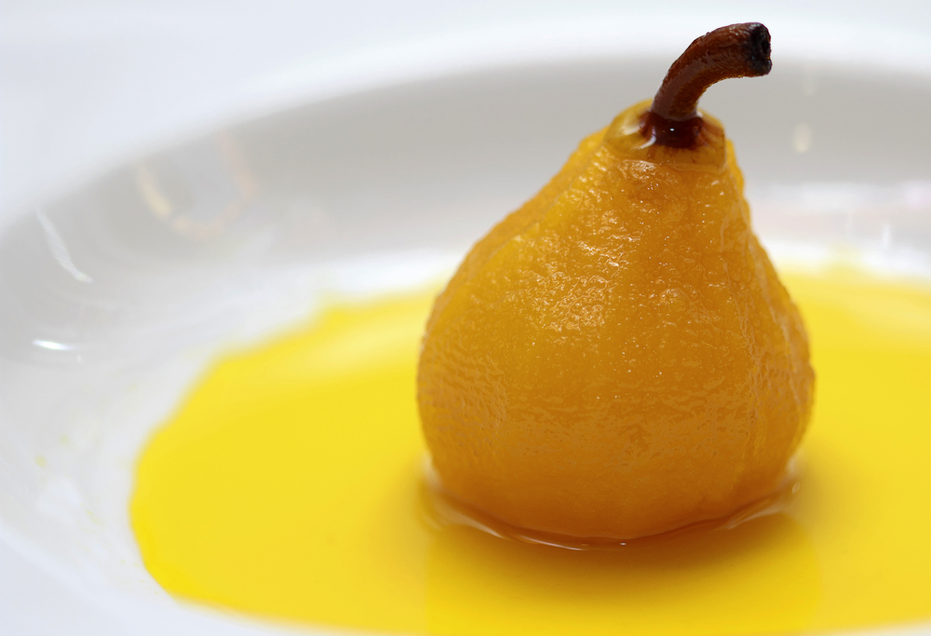
2 pears
150ml water
300ml apple juice
2 x 5ml spoons honey
2 x 15ml spoons ricotta
Pinch of cinnamon

Equipment
Saucepan, measuring jug, measuring spoons.

Method
- Peel and core the pears.
- Bring to the boil the water and apple juice and carefully add the pears.
- Cook until soft, approximately 5-10 minutes.
- Once cooked remove from the poaching liquid.
- Serve with a spoon of ricotta and sprinkle over the cinnamon and a drizzle of honey.

Top tips
- Try poaching other fruits such as apples, nectarines or plums.
- Try low fat crème fraiche, for serving instead of ricotta cheese.
- Toast some flaked almonds and sprinkle over instead of the cinnamon.

Food skills
- Measure.
- Peel.
- Core.
- Boil and simmer.

