Porridge
Ingredients
Complexity: low-medium
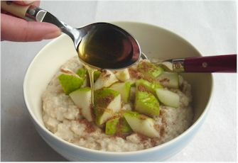
50g oats
200ml water
200ml semi-skimmed milk
25g blackberries or half a banana or 1 pear
¼ x5ml spoon cinnamon
1x5ml spoon honey

Equipment
Saucepan, measuring jug, wooden spoon, serving dishes, measuring spoons.

Method
- Put the oats into a saucepan.
- Stir in the water and milk and bring to the boil.
- Allow to simmer for 10 minutes.
- Pour the porridge into 2 bowls.
- Peel and slice the banana or pear if using.
- Stir in the fruit, cinnamon and honey.

Top tips
- If in a hurry, make a microwave porridge sachet and add a handful of fruit, e.g. chopped banana, berries or canned peaches.
- Add a handful of muesli to the porridge.
- Make a bircher:
- put the oats in a bowl, pour over the milk and add a small portion of maple syrup and lemon juice;
- mix and put in the fridge overnight;
- in the morning add fresh fruit such as raspberries or blackberries.

Food skills
- Weigh.
- Measure.
- Boil and simmer.
- Peel.
- Slice.
- Stir.

