Potato wedges
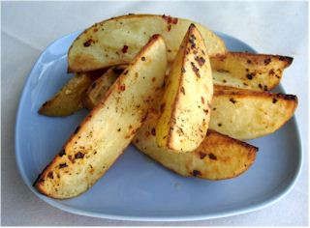
Ingredients
3 large potatoes
Complexity: low-medium
Spray oil
Chilli flakes
Black pepper

Equipment
Chopping board, sharp knife, measuring spoon, poly bag/mixing bowl, baking tray.

Method
- Preheat the oven to 200ºC or gas mark 6.
- Cut potatoes into wedges. Put into a poly bag or mixing bowl.
- Spray the oil on the wedges and add the other seasonings.
- Shake/mix.
- Place on baking tray and bake for 20-30 minutes.

Top tips
- Use sweet potatoes for a twist.
- Vary the seasoning, e.g. garlic, herbs, spices, pesto.
- Have plain wedges – great for dipping in ketchup!

Food skills
- Cut.
- Bake.

