Roasted butternut squash risotto
Ingredients
Complexity: medium-high
1 butternut squash
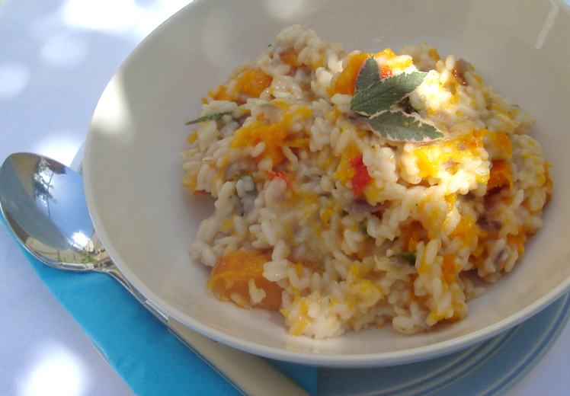
2 cloves garlic
½ red chilli
1 red onion, chopped
1 x 15ml spoon parmesan
1 x 15ml spoon sage
Spray oil
250g risotto rice
1-1.5L boiling water
1 reduced salt vegetable stock cube

Equipment
Chopping board, knife, baking dish, garlic press, grater, frying pan, spoon, kettle, measuring jug.

Method
- Preheat the oven to 200ºC or gas mark 6.
- Prepare the vegetables:
  - cut the butternut squash in quarters or into large pieces – place into a baking dish;
  - peel and crush the garlic;
  - deseed and finely dice the chilli;
  - peel and finely dice the onion;
  - grate the cheese;
  - chop the sage.
- Spread one clove of garlic over the squash, sprinkle with the chilli and spray with the oil. Roast for 40 minutes.
- Add some spray oil to the frying pan and fry the onion and garlic for 4 minutes.
- Stir in the rice.
- Make up the stock using boiling water.
- Add a little of stock at a time. Wait for the stock to be adsorbed. Stir constantly.
- Continue adding the stock until the rice cooks – this will take 20-30 minutes.
- Scoop out the butternut squash flesh from the skin.
- Stir the roasted butternut squash, parmesan and sage into the rice.
- Serve.

Top tips
- Make a basic risotto and add whatever vegetables, fish or meat you have.
- To save time, use ready prepared or frozen butternut squash.
- After the butternut squash has been roasting for 20 minutes, pour over a can of chopped tomatoes, garlic and a little water – cover and cook for another 20-30 minutes – serve with pasta.

Food skills
- Weigh.
- Measure.
- Cut, chop and dice.
- Peel.
- Crush.
- Spread.
- Stir.
- Simmer.

