Roasted vegetables
Ingredients
Complexity: low-medium
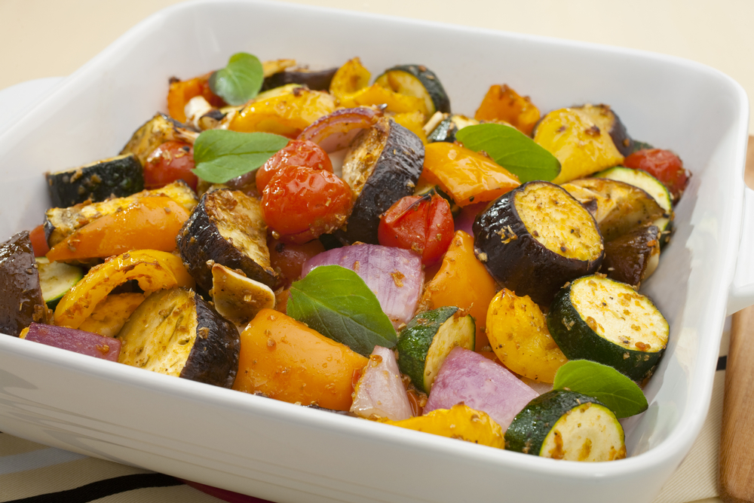
1 red onion
1 courgette
2 tomatoes
1 pepper
1 clove of garlic
Spray oil

Equipment
Chopping board, knife, measuring spoon, oven dish.

Method
- Preheat the oven to 200ºC or gas mark 6.
- Prepare the vegetables:
  - peel the onion and cut into wedges;
  - top, tail and slice the courgette;
  - halve the tomatoes;
  - deseed and thickly slice the pepper;
  - peel and crush the garlic.
- Place the vegetables and garlic in an oven proof dish and spray with oil
- Roast for 20-30 minutes.

Top tips
- Be creative and use different types of vegetables, why not try: beetroot, celeriac or fennel?
- Add a kick and pop-in a few slices of red chilli.
- Use left-over roasted vegetables to make a soup
  - make up some stock with hot water;
  - blend the vegetable with stock;
  - reheat and serve – simple!

Food skills
- Peel.
- Cut, trim and slice.
- Crush.
- Roast.

