Tandoori chicken
Ingredients
Complexity: low-medium
1-2 x 15ml spoons tandoori paste
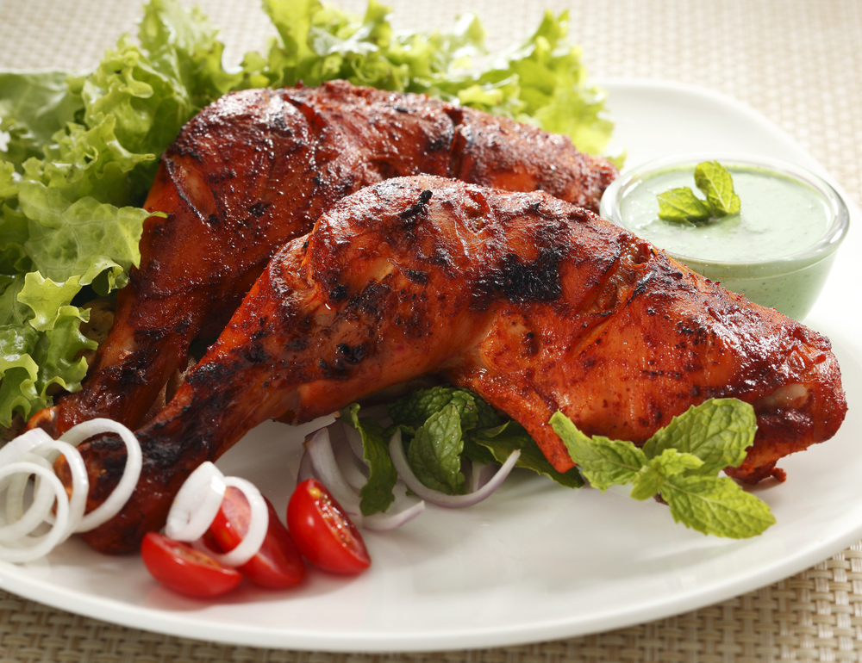
4 x 15ml spoons low fat plain yogurt
½ lemon
8 chicken drumsticks or 2 chicken legs

Equipment
Large bowl, measuring spoons, spoon, red chopping board, sharp knife, tongs.

Method
- Cut the lemon in half and juice.
- Mix the tandoori paste, yogurt and lemon juice together in a small bowl.
- Remove the chicken skin. Thoroughly wash and dry your hands after touching the raw meat.
- Score the chicken with a sharp knife.
- Cover the chicken with the tandoori mix. Allow to marinade for 2 hours, preferably overnight.
- Barbeque, grill or oven bake, turning occasionally (15-20 minutes). Ensure that the chicken is completely cooked through – the juices run clear and no pink meat remains.
- Serve with a green salad, mint yogurt dressing and rice.

Top tips
- Removing the skin from the chicken leg will help to reduce the amount of fat in the meal.
- You can also use chicken breast, however chicken legs tend to be cheaper - just remember to remove the skin!

Food skills
- Measure.
- Cut.
- Juice.
- Mix.
- Grill.

