Vegetable couscous
Ingredients
Complexity: medium
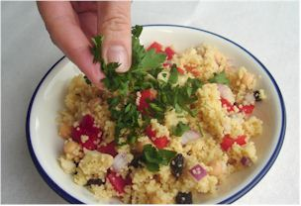
360ml boiling water
1 reduced salt stock cube
200g couscous
1 red onion
1 red pepper
50g almond flakes
100g canned chickpeas
2 x 15ml spoons parsley
50g raisins

Equipment
Kettle, measuring jug, spoon, large bowl, fork, chopping board, sharp knife, can opener, colander.

Method
- Make up the stock: dissolve the stock cube in the boiling water.
- Pour the stock over the couscous in a large bowl.
- Fluff with a fork and leave to stand for 5 minutes.
- Prepare the other ingredients:
  - peel and finely dice the onion;
  - deseed and finely dice the red pepper;
  - under a hot grill, toast the almonds;
  - drain the chickpeas;
  - chop the parsley.
- Mix the onion, pepper, almonds, chickpeas and raisins with the couscous.
- Sprinkle the parsley on top to serve.

Top tips
- Vary the vegetables in the couscous dish, e.g. celery, spring onion, sweetcorn, peas, olives, mushrooms.
- Replace the chickpeas with chopped cooked chicken, ham, tuna or chunks of feta cheese.
- Add chopped apricots and omit the raisins and almonds.
- As stock cubes are high in salt, try using half the stock cube in the couscous and add more herbs or lemon juice for flavour.
Food skills
- Weigh.
- Measure.
- Peel, dice and chop.
- Grill.
- Mix.

