Basic tomato sauce
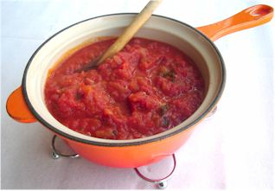
Ingredients
1 onion
Complexity: medium
1 clove of garlic
Handful of fresh basil or 1x15ml spoon dried herbs
Spray oil
2 large cans chopped tomatoes
Black pepper
75g dried pasta per person

Equipment
Knife, chopping board, garlic press, two saucepans, wooden spoon.

Method
- Prepare the ingredients:
  - peel and finely dice the onion;
  - peel and crush the garlic;
  - chop the basil.
- Heat the oil and fry the onion and garlic for 5 minutes, until soft.
- Add the tomatoes, basil and pepper.
- Allow to simmer gently for 30 minutes (longer if possible).
- Cook the pasta following the instructions on the packet.
- Drain and serve with the tomato sauce.

Top tips
- Add ½ red chilli, for a sauce with a kick.
- Add 75g mushrooms and 75g courgette, after stage 2, for a simple veggie sauce.
- Add and brown lean 200g beef mince after stage 2 for a simple meat sauce.
- Stir-in black olives and tuna.
- Pour the basic sauce over white fish, sprinkle with cheese and bake for 20 minutes until golden.

Food skills
- Peel.
- Dice and chop.
- Crush.
- Fry.
- Boil and simmer.

