Chicken (tofu) stir fry
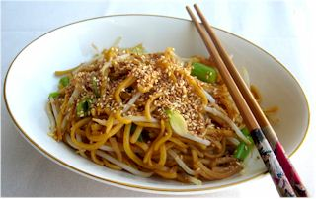
Ingredients
Spray oil
Complexity: medium-high
1 x chicken breast (or 3-4 thighs) or 100g tofu
½ red chilli
1 clove of garlic
1cm fresh ginger (optional)
½ red onion
1/3 green pepper
1/3 yellow pepper
2-3 mushrooms
1x10ml spoon reduced salt soy sauce

Equipment
Chopping board, knife, garlic press, wok/saucepan, measuring spoon.

Method
- If using chicken, cut into thin strips. Place in the fridge, covered, until needed.
- Using a clean chopping board and knife, prepare the vegetables:
  - deseed and finely slice the chilli;
  - peel and crush the garlic;
  - peel and finely chop the ginger;
  - peel and finely slice the onion
  - deseed and finely slice the green and yellow peppers
  - wash or wipe the mushrooms and slice.
- Heat the oil in the wok/saucepan.
- Add the onion, garlic, chilli and ginger. Allow to cook for 1 minute.
- Add the chicken or tofu and stir-fry for 4-5 minutes.
- If using chicken, check that it is cooked through and no pink remains.
- Add the remaining vegetables and soy sauce and continue to cook for a further 2 minutes.
- Serve.

Top tips
- Try different vegetables - leeks, courgettes and carrots all work well.
- Other types of meat could be used, e.g. thin strips of beef or turkey.
- Mix in ready cooked noodles or rice for a quick main meal.

Food skills
- Measure.
- Peel.
- Crush, slice and chop.
- Stir fry.
- Boil and simmer.

