Apple and carrot juice
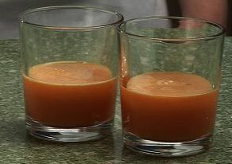
Ingredients
2 large carrots
Complexity: low-medium
2 eating apples

Equipment
Chopping board, vegetable knife, bowl, juicer, fork, 2 small glasses.

Method
- Cut away the top and bottom from each carrot.
- Cut the carrots into pieces that will fit into the top of the juicer and place them into the bowl.
- Cut each apple into 8 pieces and place them in the bowl - remember to check that the pieces will fit into the juicer.
- Switch on the juicer, and push the apple pieces into the juicer – mind your fingers!
- Next, add the carrot pieces.
- Turn off the juicer.
- Whisk the juice and pour into the glasses.

Top tips
- Use other fruit and vegetables, such as orange and ginger.

Food skills
- Trim.
- Cut.
- Juice.
- Whisk.

