Chapatti
Complexity: low-medium

Ingredients

100g plain flour

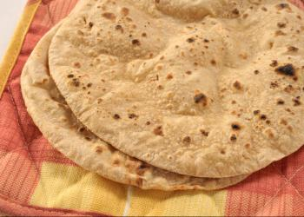
½ x 5ml spoon salt

1 x 15ml spoon vegetable oil or corn oil

125–150ml warm water

40–50g butter (or ghee)

Equipment
Sieve, measuring scales, measuring spoons, bread board, rolling pin, large mixing bowl, cling film, non-stick frying pan, tablespoon, palette knife, wooden spoon, pastry brush.

Method
- Sift the flour and salt into a mixing bowl.
- Make a well and pour in the oil and half the water.
- Mix well with a wooden spoon and continue adding enough water until you have a firm, soft but not too sticky dough.
- Knead the dough for 3–4 minutes.
- Divide the dough into 4 equal balls.
- Lightly flour a surface and roll each dough ball into a thin circle.
- Gently melt the butter/ghee in a saucepan or the microwave.
- Spread each chapatti with a light spreading of ghee/melted butter.
- Fold the chapatti into quarters to enclose the ghee/butter mixture.
- Re-roll into a flat round pizza shape.
- Fry in a dry pan for 3–4 minutes on each side until lightly coloured, brushing a little of the ghee/butter mixture on each side during cooking.
- Remove from the pan and leave to cool.

Top tips
- Add chopped nuts or grated coconut to the dough before adding the liquid.

Food skills
- Weigh.
- Measure.
- Sift.
- Mix.
- Divide.
- Roll out.
- Melt.
- Spread.
- Fry.

