Potato varieties: fact sheet
C
0
Potato varieties
There are over 4,000 edible types or ‘varieties’ of potato and they are many different colours, shapes and sizes! Potatoes can have white, brown, purple or red skin and white or gold flesh.

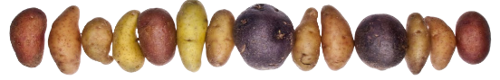
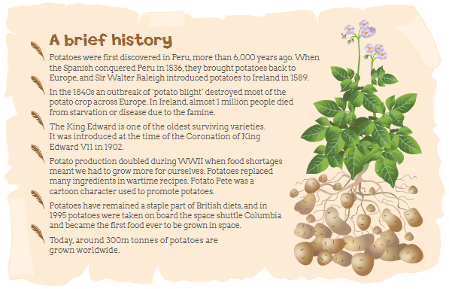
British varieties
Around 80% of all the potatoes we eat are ‘home grown’. Approximately 100 different varieties are grown in Great Britain, but only 20 or so are widely available in the shops. The varieties that you see may depend on the region or the season. Potatoes are often referred to as ‘new’ (harvested in early summer) and ‘old’ (harvested in autumn). The average person in Britain eats around 500 ‘spuds’ a year

New varieties
Specialist potato breeders work to create new varieties, with better qualities: For example:
- Increased resistance to pests and diseases
- Better storage qualities
- Greater nutritional value
- Increased ‘yield’ (the number of
- potatoes produced on a piece of land)
- Better eating quality and appearance
- Reduced needs for inputs such as water and fertiliser

Know your potatoes
Although every variety is different, potatoes can be divided into three groups or types.
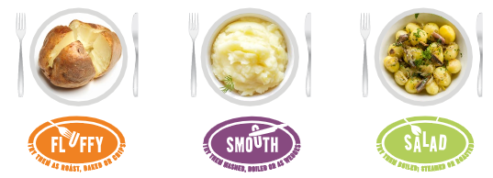

Characteristics
Before cooking  - Bright, granular with a drier feel  When cooked  - Fluffy in the middle, soft dry texture | Before cooking  - Bright, granular with a drier feel  When cooked  - Smooth texture. Hold shape when boiled or cooked in a sauce such as Dauphinoise, a hot pot or soup | Before cooking  - Transluscent, firm, moist, pasty  When cooked  - Hold their shape well. Firm to the bite
Preparation and Cooking
Perfect for  - Roasting, baking and chipping | Perfect for  - Mashing, boiling or wedges | Perfect for  - Boiling, steaming, roasting and salads
Popular varieties
King Edward, Maris Piper | Desiree | Charlotte, Maris Peer
Other varieties
Arra Victory, Cara, Dunbar, Rover, Fianna, Golden Wonder, Highland Burgudy, Innovator, Kerr’s Pink, Mayan Gold, Red Duke of York, Red King Edward, Rooster, Sante, Shetland Black, Violetta, Yukon Gold | Accord, Apache, Chopin, Dunford, Estima, Harmony, Lady Balfour, Marabel, Marfna, Maris Bard, Melody, Mozart, Nadine, Vivaldi | Annabelle, Anya, Bambino, Carlingford , Corolle, Duke of York, Exquisa, Galante, Inca Dawn, Jazzy, Kestrel, Pink Fir Apple, Nicola, Pentland Javelin, Baby Gem

The science behind the cooking
Although every variety is different, potatoes can be divided into three groups or types. Varieties: fact sheet www.cookyourownpotatoes.org.uk Potatoes vary from having a smooth to a fluffy texture when they are cooked. The different textures are due to changes that happen to potato cells during cooking.
During cooking the starch in the potato begins to absorb water and swells in size. The starch cells of new potatoes are younger and stronger which means they hold their shape well.

