Potato farming in Great Britain

Great Britain is one of the largest producers of potatoes in the world.

Approximately 5.4 million tonnes of potatoes are produced each year in Great Britain. The GB potato industry directly employs around 16,000 people.

There are over 2,000 specialist growers in Great Britain.

Potatoes are planted on over 100,000 hectares of arable land. Around 80% of the potatoes we eat are ‘home grown’ in Great Britain.

Nearly 100 varieties are grown in 50 British counties. Over 40% of the total planted area for potatoes in Great Britain is in eastern England (eastern counties and East Midlands).

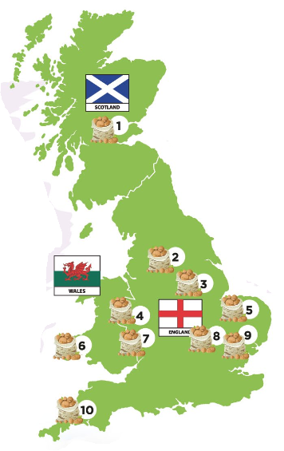
Scotland grows nearly a quarter of
the GB potato crop.

40% of potatoes grown in Scotland are
seed potatoes for growing rather than
eating.

.org.uk
Farming: fact sheet

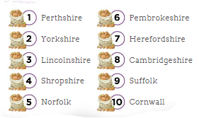

Potato Farming: The Journey from Field to Fork

1. Choosing where to plant
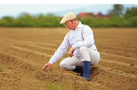
Soil is tested for nutrients and moisture content to see
if it is suitable for potato growing and to decide which
varieties to grow. Potatoes will usually be grown in the
same field for only one out of every six years, or even longer. This is known as a rotation. Grass, cereals and other crops are grown during the other years to replenish
the nutrients and improve soil health.

2. Preparing to plant
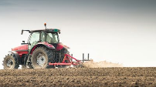
First, farmers plough the ground and turn the soil.
Later in the spring, the farmer spreads fertiliser and
often uses a stone separator to remove stones from
the soil where the potatoes are growing. Modern
automatic harvesters cannot differentiate between
stones and potatoes!

3. Planting

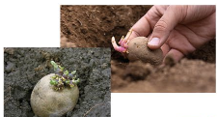
Seed potatoes are planted in rows and covered with soil,
about 15-17cm deep.
Planting usually takes place in spring, but depends on the
climate. For example, farmers in Cornwall can plant and
harvest potatoes much earlier than farmers in Scotland.
These differences make potatoes more sustainable as it
means GB-grown potatoes are available all year round.

4. Protecting the crop
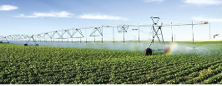
Farmers care for their potato crops as they grow,
using plant protection products to guard against
insects and disease.

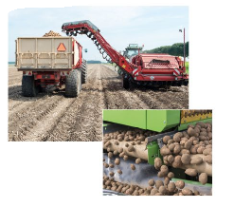
5. Harvesting

Potatoes are grown for around 5 months before they
are ready for harvesting. Harvesting can start as
early as June and finish at the end of October.
To see if the crops are ready, farmers test the crops by
digging up, weighing and measuring sample potatoes.
The potatoes are then lifted by the harvester. Small
and damaged potatoes are removed.

6. Storage
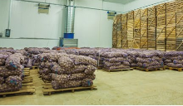
Potatoes are placed in bulk storage or weighed
and bagged ready for distribution. Potatoes
can also be stored in boxes in an insulated
potato store. Farmers will check the potatoes
regularly throughout the storage season.

7. Next steps

Not all potatoes are sent to supermarkets and other shops. Many are used for:

Future crops – Potatoes are reproduced from other potatoes. Traditionally, a part of each year’s crop is set aside for reuse in next year’s planting season

Manufacture of potato crisps – Potatoes are delivered to factories where they are washed, peeled, sliced, fried in hot oil and flavoured, before being packaged and sent to retailers

Ready prepared potato products – British manufacturers of frozen potato products such as frozen chips, are the largest purchasers of British potatoes

