Spicy potato Scotch eggs
Complexity: low-medium

Ingredients

4 eggs

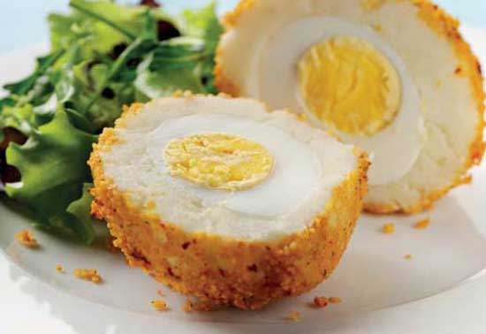
500g leftover mashed potato

Freshly ground black pepper

150g packet couscous (flavour of your choice)

Equipment
Small saucepan, large bowl, kettle, large plate, baking tray.

Method
- Hard boil eggs, then once cooled, remove all shell.
- Whilst eggs are cooling, cook the couscous according to the packet instructions, if plain, flavour with spice like Cajun.
- Coat cooled eggs in 0.5 to 1cm of potato which has been seasoned with black pepper.
- Roll in cooked couscous.
- Shape into a ball, make sure all eggs are even.
- Bake in the oven for 5-7mins or until crisp.

Top tips
- Use quails eggs for bite sized Scotch eggs perfect for a finger buffet!

Food skills
- Weigh.
- Boil and simmer.
- Form and shape.
- Bake.

