Easy Bombay potato curry
Complexity: medium

Ingredients

500g new potatoes

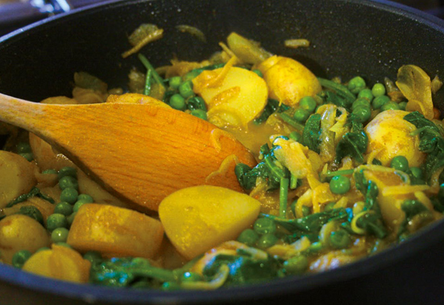
1 x 15ml spoon oil

1 large onion

1 x 5ml spoon turmeric

1 x 5ml spoon cumin powder

1 x 5ml spoon coriander powder

¼ x 5ml spoon dried chilli flakes

100g frozen peas

1 handful baby spinach

Equipment
Frying pan, wooden spoon, measuring jug, vegetable knife, serving dish.

Method
- Prepare the ingredients:
  - cut the potatoes into bite sized pieces;
  - peel and slice the onion.
- Heat the oil in a frying pan and cook the onion over a medium heat until soft and slightly caramelised, about 10 minutes.
- Add the spices and chilli and cook for a couple of minutes, stirring continuously to release the flavours.
- Add enough water to cover the ingredients and simmer gently for 10 minutes.
- Add the potatoes to the pan, cover and cook until they are tender – about 10 minutes
- Add the peas five minutes before the end of cooking stir and replace the lid.
- Remove from the heat and stir in the spinach until wilted.

Top tips
- Serve with a fresh raita made from reduce fat natural yogurt, grated cucumber and 1 x 5ml spoon mint sauce.

Food skills
- Weigh.
- Measure.
- Cut.
- Peel.
- Slice.
- Fry.
- Boil and simmer.

