Potato and chicken curry
Complexity: medium

Ingredients

300g salad potatoes e.g. Charlotte

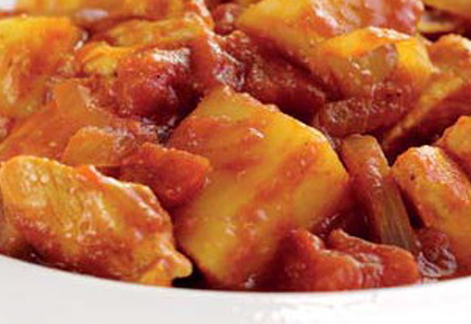
1 x 15ml spoon rapeseed oil

2 small chicken breasts (approx. 250g)

1 onion, (approx. 150g)

1 x 15ml spoon medium madras curry powder

400g can chopped tomatoes

50ml water

For the raita:

150g tub fat-free natural yogurt

¼ cucumber

1 x 15ml spoon fresh mint

Equipment
Scales, knife, chopping board, saucepan with lid, colander, measuring spoons, frying pan with lid, wooden spoon, can opener, small mixing bowl, grater.

Method
- Prepare the ingredients:
  - dice the potatoes;
  - cut the chicken into small pieces;
  - peel and slice the onion;
  - deseed and grate the cucumber;
  - chop the mint.
- Cook the potatoes in boiling water for 10 minutes, drain.
- Meanwhile, heat the oil in a frying pan and fry the chicken and onion for 5 minutes until browned. Add the curry powder and cook for 1 minute.
- Stir in the tomatoes and 50ml water, cover and simmer gently for 5 minutes. Stir in the cooked potatoes and cook for a further 5 minutes.
- Meanwhile, stir all the raita ingredients together and serve with the curry.

Top tips
- Add a variety of different vegetables such as sliced okra, aubergine or spinach.

Food skills
- Weigh.
- Measure.
- Peel.
- Cut, dice and slice.
- Boil and simmer.
- Drain.
- Fry.
- Stir.
- Mix.

