Potato and courgette frittata
Complexity: low-medium

Ingredients

1 large onion

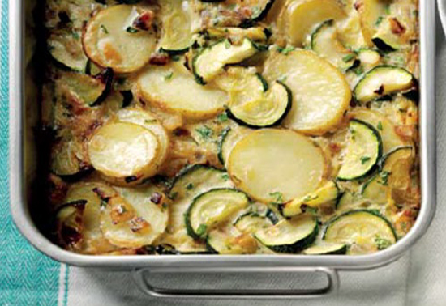
2 courgettes

1 x 15ml spoon oil

2-3 cloves of garlic (optional)

4 eggs

1 x 15ml spoon fresh herbs, or 1 x 5ml spoon dried herbs, or 2 x 15ml spoons pesto

A handful of cooked potatoes

Fat or oil to grease baking dish

Equipment
Frying pan, wooden spoon, vegetable knife, large bowl, fork, baking dish (greased and lined with baking parchment), oven gloves.

Method
- Pre-heat the oven to 200˚C.
- Prepare the ingredients:
  - peel and slice the onions;
  - slice the courgette;
  - crush the garlic (if using);
  - chop the herbs;
  - slice the cooked potatoes.
- In a large frying pan, fry the onions and courgettes together in the oil until the onion is translucent and the courgettes are softening. Add the garlic about two minutes before you think the onions and courgettes will be ready – there’s less risk of overcooking it this way.
- In a large bowl, beat the eggs with the herbs or pesto, then stir in the cooked vegetables and sliced potatoes and mix thoroughly.
- Pour the mixture into a greased, lined, baking dish and bake for 20-25 minutes until puffy and golden.

Top tips
- Serve with a crisp green salad and fresh crusty bread.

Food skills
- Measure.
- Peel.
- Slice and chop.
- Crush.
- Fry.
- Beat.
- Bake.

