Potato nests
Complexity: medium

Ingredients

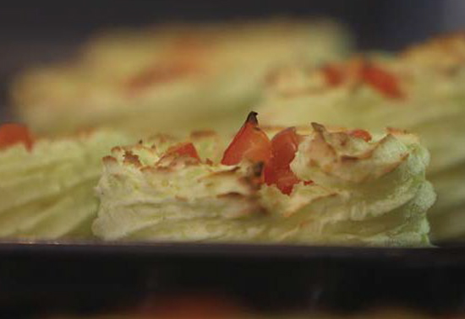
500g ‘smooth’ variety
(Desiree, Melody and Orla are all good)

2 medium sized tomatoes

Freshly ground pepper

Equipment
Colander, chopping board, potato peeler, large saucepan with a lid, vegetable knife, potato masher/ricer, teaspoon, disposable piping bag, non-stick baking tray, oven gloves, serving plate.

Method
- Pre-heat the oven to 200C.
- It’s a good idea to wash the potatoes under cold running water to remove any dirt. Peel the washed potatoes with a potato peeler and place into a pan of cold water to stop them going brown.
- Cut the potatoes into similar size pieces so they cook evenly and place back in the water, drain the cloudy water away and replace with fresh cold water.
- Place the pan on the hob to boil. From boiling, allow fifteen minutes for these to cook. To test if they are cooked through, press a sharp knife into one of the bigger pieces and if it’s soft, it’s cooked. These can be drained in a colander and returned to the hob for thirty seconds to dry out.
- Remove the pan from the hob and mash these thoroughly until all lumps have been removed, season to taste with ground pepper.
- While these are cooling slightly, cut the tomatoes into quarters and remove the seeds with a knife or if you prefer use a teaspoon, cut the tomato flesh into a small dice and set aside.
- Make sure the potato has cooled enough for you to hold in your hand, half fill a disposable piping bag with the warm mash. Here’s where the fun starts! Pipe your potato nests onto a non-stick baking tray, they want to be about 8 cm in diameter and about 3 – 4 cm high (the size of a meringue nest)
- Fill the middle with the diced tomato and bake in the oven for 10 – 15 minutes or until they start to go a lovely golden brown colour. These are now ready to enjoy on their own, as a light lunch, or as part of an evening meal.

Top tips
- Serve with baked meat or fish and a variety of colourful steamed vegetables.

Food skills
- Weigh.
- Peel.
- Cut and dice.
- Boil and simmer.
- Mash.
- Pipe.
- Bake.

