Smoked mackerel and pancetta
potato salad
Complexity: medium

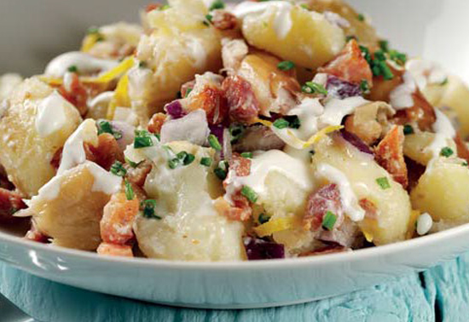
Ingredients

350g new potatoes

1 lemon

½ red onion

100g pancetta (or streaky bacon)

100g crème fraîche

2 tsp horseradish cream

2 smoked mackerel fillets (about 200g)

1 tbsp parsley (or chives)

Black pepper

Equipment
Saucepan and lid, colander, grater, vegetable knife, tablespoon, frying pan, kitchen paper, mixing bowl, serving dish.

Method
- Prepare the ingredients:
  - wash the potatoes;
  - zest and juice the lemon;
  - finely chop the onion;
  - cut the bacon into small chunks;
  - skin and flake the mackerel;
  - finely chop the herbs.
- Cook the potatoes until tender in a pan of boiling. Drain well, then return to the heat briefly to dry out.
- Add the lemon zest and red onion to the potatoes while they are still hot and lightly break up the potatoes with a fork.
- Fry the pancetta in a dry pan until golden and crispy and drain off any excess fat on kitchen paper.
- Combine the crème fraîche, lemon juice and horseradish cream.
- Add the smoked mackerel, horseradish dressing and pancetta to the potatoes.
- Sprinkle with parsley, season with freshly ground black pepper and serve while warm.

Top tips
- Add frozen peas and sweetcorn for extra colour.

Food skills
- Weigh.
- Measure.
- Zest.
- Juice.
- Chop and cut.
- Boil and simmer.
- Fry.
- Stir.
- Mix.

