Stuffed peppers

Ingredients
Complexity: medium
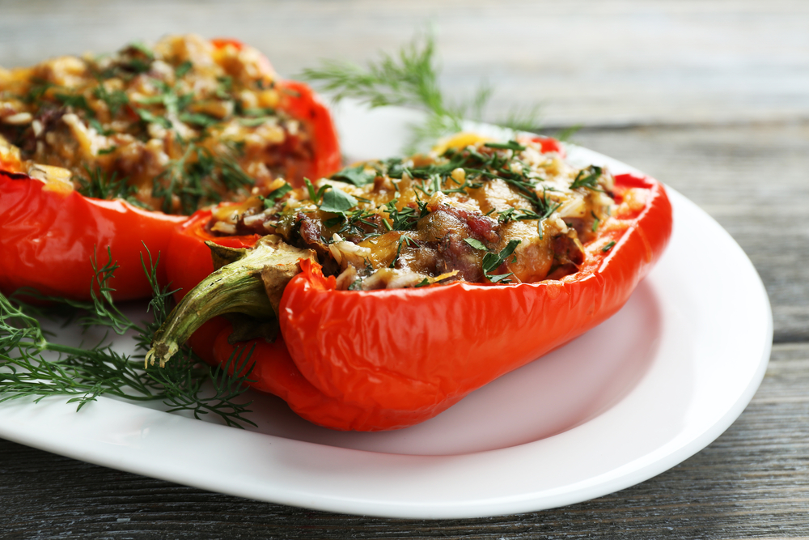
1 lime
2 red peppers
150g lamb mince
75g couscous
1 x reduced salt lamb or vegetable stock cube
50ml boiling water
1x 15ml spoon sunflower seeds (optional)
1x 15ml spoon pumpkin seeds (optional)
80g ready prepared pomegranate seeds

Equipment
Grater, juicer, knife, chopping board, baking dish, measuring jug, kettle, mixing bowl, fork, non-stick frying pan, fish slice, tongs and mixing spoon.

Method
- Pre-heat the oven to 200°C, gas mark 6.
- Prepare the ingredients:
- zest and juice the lime;
- deseed the red peppers. Finely chop one pepper and cut the other pepper into two halves.
- Place the two halves into a baking dish and cook in the oven for 15 minutes until softened.
- Make up the stock by dissolving the stock cube in the boiling water in a jug.
- Pour the stock over the couscous in a large bowl. Cover and leave to stand for five minutes then fluff up with a fork.
- Dry fry the lamb mince and chopped pepper in a non-stick frying pan for 8-10 minutes until starting to brown. Thoroughly wash hands after touching raw meat. Carefully drain off any excess liquid.
- Add the cooked lamb, pomegranate seeds, lime zest and juice, sunflower and pumpkin seeds, if using, to the couscous and mix well.
- Serve the lamb mixture in the two halves of cooked pepper.

Top tips
- Add a variety of vegetables to the dish, e.g. sweetcorn, peas, olives or mushrooms.
- Use chopped dried apricots or raisins instead of the pomegranate seeds.
- Use flaked almonds instead of the sunflower and pumpkin seeds.

Food skills
- Weigh.
- Measure.
- Bake.
- Zest.
- Chop.
- Fry.
- Drain.
- Combine.

