Quick lamb kebabs

Ingredients
Complexity: medium
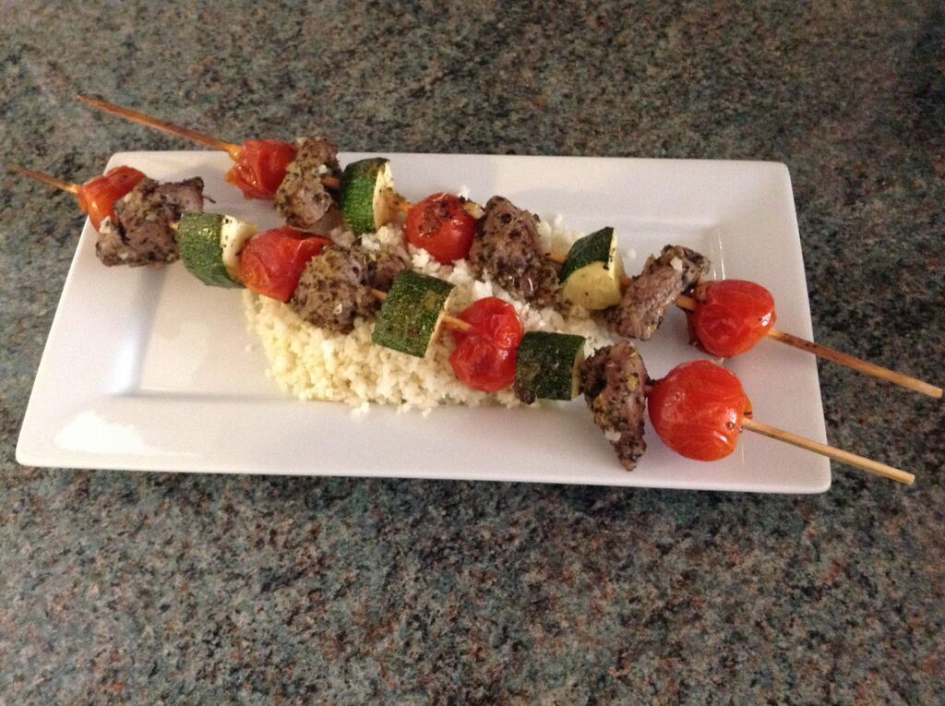
1 large garlic clove
1 x 15ml spoon dried oregano or mint
2 x 5ml spoon olive oil
Freshly ground black pepper
250g lean boneless lamb leg, shoulder or steaks
½ a yellow pepper
1 courgette
8 cherry tomatoes

Equipment
8 small or 4 large wooden or metal skewers, chopping board, garlic press, 2 x knives, red chopping board, mixing bowl.

Method
- Preheat the grill to medium heat.
- Peel and crush the garlic.
- Add the crushed garlic, olive oil, dried herbs and black pepper to a mixing bowl and stir well.
- Using a clean knife and separate chopping board cut the lamb into 2.5cm/1 inch cubes. Thoroughly wash and dry hands after touching raw meat.
- Add the cubed meat to the marinade and mix well.
- Prepare the vegetables:
  - deseed and slice the pepper into 2.5cm cubes;
  - top and tail the courgette and cut into 2.5cm cubes.
- Add the vegetables to the marinated lamb and mix well.
- Thread the lamb, pepper, courgette and cherry tomatoes onto 4 short or 2 long wooden (previously soaked) or metal skewers.
- Cook the kebabs under the pre-heated grill for 12-16 minutes, turning occasionally until any meat juices run clear.

Top tips
- Use a red chopping board to help prevent cross-contamination.
- Try adding halloumi or paneer cheese.
- If time allows, leave the meat to marinate covered in the fridge before use.
- Line the grill tray with tin foil to make washing up easier.
- If using wooden skewers, soak in water to prevent burning during cooking.

Food skills
- Weigh.
- Measure.
- Peel.
- Cut, chop, slice and trim.
- Mix.
- Grill.

