Pork and leek risotto

Ingredients
Complexity: medium
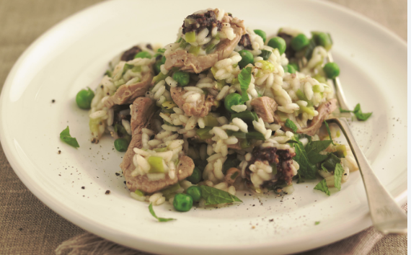
110g pork fillet (tenderloin)
1 garlic clove
1 small leek
1 reduced salt vegetable or pork stock cube
1x5ml spoon olive oil
110g risotto rice
1 x 5ml spoon dried herbs
85g frozen peas
2x15ml spoon Parmesan cheese, optional

Equipment
Red chopping board, sharp knife, chopping board, 2 x small bowls, garlic crusher, vegetable knife, measuring jug, large saucepan with a lid, wooden spoon, grater.

Method
- Trim and cut the pork fillet (tenderloin) into thin slices. Use a red board and thoroughly wash and dry your hands after touching the raw meat.
- Prepare the vegetables:
- peel and crush the garlic clove;
- wash the leek, top and tail and slice thinly.
- Dissolve the stock cube in a jug with 500ml (18floz) of boiling water.
- Heat the oil in a large saucepan over a moderate heat, add the pork slices, garlic and leeks and cook until lightly browned.
- Add the rice and dried herbs, stir well and then add most of the stock. Keep a little stock in reserve to add later if necessary.
- Place the lid on the pan and simmer for 15 minutes. Stir occasionally to prevent the rice from sticking to the bottom of the pan.
- Add the remaining stock to the pan if necessary.
- Grate the Parmesan cheese, if using, and scatter over the risotto.

Top tips
- Cook the rice until it is ‘al dente’, which means firm to the bite or ‘to the tooth’ in Italian
- Try adding different ingredients, such as chorizo or bacon instead of the pork; grated courgette, grated beetroot or mushrooms instead of the peas.
- Try different dried herbs, such as mint or basil.

Food skills
- Weigh
- Measure.
- Cut and trim.
- Peel.
- Fry.
- Simmer.
- Grate.

