Chilli ginger beef

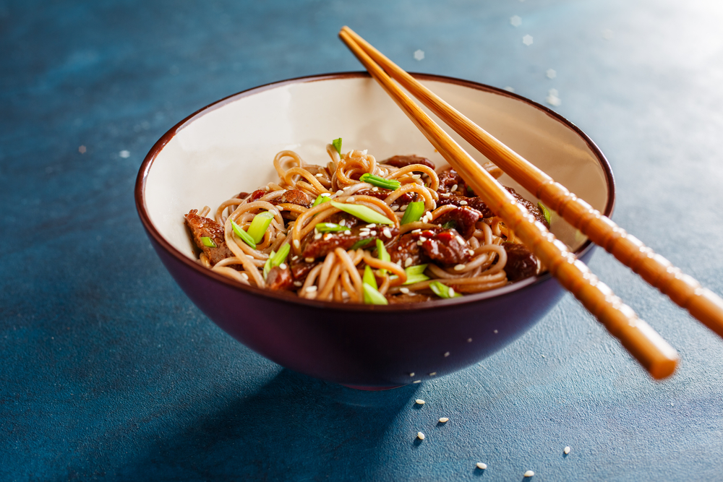
Ingredients
Complexity: medium-high
2 spring onions
1 clove of garlic
½ red chilli
2.5cm root ginger
1 whole lime
400g stir fry vegetables, e.g. beansprouts, red pepper, sweetcorn, mushrooms or broccoli
150g quick cook noodles or 1 packet ‘Ready to wok’ noodles
Spray oil
200g stir fry beef strips or rump steak
2 x 5ml soy sauce (reduced salt)

Equipment
Vegetable knife, chopping board, garlic crusher, grater, zester, juicer, saucepan, colander, wok or frying pan, wooden spoon.

Method
- Prepare the vegetables:
- trim and slice the spring onions;
- peel and crush the garlic;
- deseed the chilli and finely dice (thoroughly wash hands after touching the chilli);
- peel and grate the root ginger;
- zest and juice the lime;
- trim, deseed, slice or dice any additional ingredients.
- If using dried noodles, bring a pan of water to the boil and cook the noodles for the stated time. Carefully drain into the sink.
- Heat the spray oil in the wok or frying pan and add the garlic. Stir fry for 1 minute, but do not allow the garlic to burn.
- Add the beef strips and brown the meat all over on a high heat; this should take about 2 -3 minutes. Thoroughly wash and dry hands if touched raw meat.
- Add the spring onion, chilli, ginger, soy sauce and vegetables to the pan and stir fry for 2-3 minutes. Add the cooked noodles and stir through.
- Add the lime juice and serve sprinkled with lime zest.

Top tips
- Serve the meat and vegetables in a large lettuce leaf as an alternative to using noodles.

Food skills
- Slice.
- Peel.
- Grate.
- Zest.
- Boil
- Drain.
- Fry.
- Juice.

