Potato gratin
Complexity: low-medium

Ingredients

675g potatoes

2 tomatoes

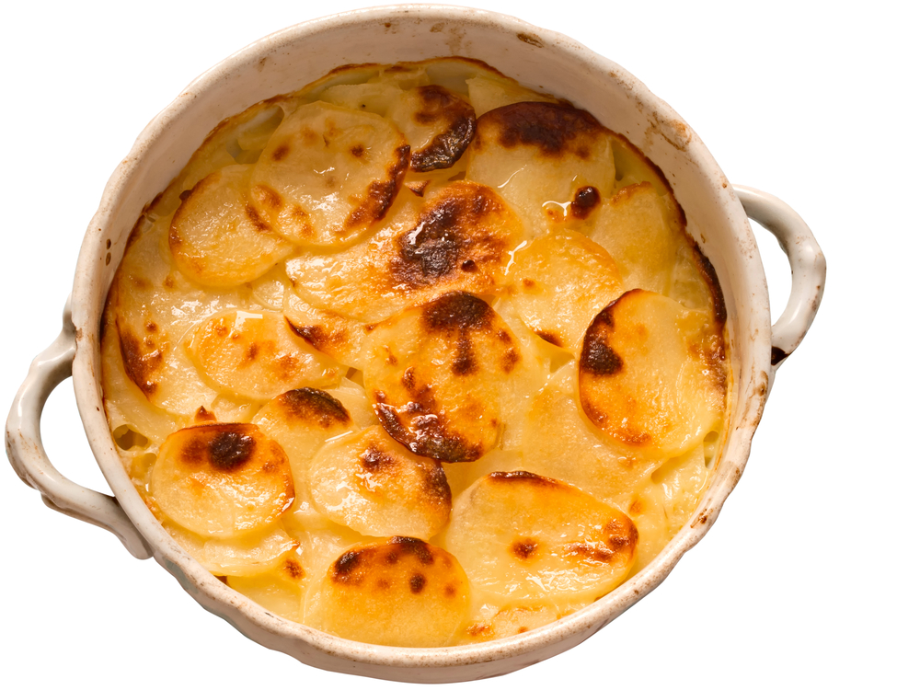
125g Cheddar cheese, grated

Freshly ground black pepper

150ml half fat crème fraiche

Equipment
Ovenproof dish, knife, chopping board, weighing scales, grater, measuring jug, 15 ml spoon, oven gloves.

Method
- Pre-heat the oven to 180°C (350°F) or Gas mark 4.
- Lightly grease an ovenproof dish.
- Prepare the ingredients:
  - peel and very thinly slice the potatoes;
  - grate the cheese;
  - slice the tomatoes.
- Cover the base of the dish with a layer of potato slices.
- Make alternate layers of potato, tomato and cheese, seasoning with pepper. Reserve approximately 25g of cheese for the top. Finish with a layer of potatoes.
- Spoon over the crème fraiche and top with the reserved cheese.
- Cook for 1¼ — 1½ hours or until the potatoes are tender and the top is golden brown — if the top is brown before the potatoes are cooked cover with foil and continuing cooking.

Top tips
- Make an additional layer with thinly sliced onion.
- Try a different cheese such as Gruyere or Emmental.

Food skills
- Peel.
- Slice.
- Grate.
- Layer.
- Bake.

