Stuffed jacket potato
Complexity: low

Ingredients

1 large floury potato

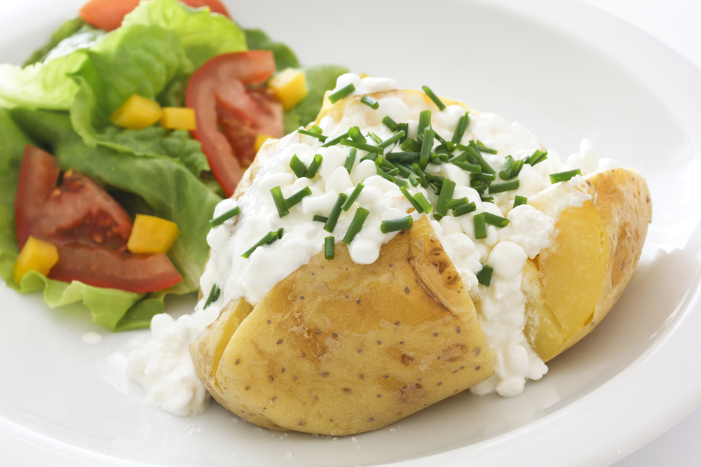
1 x 15 ml spoon canned sweet corn

1 x 15ml spoon crushed canned pineapple (in natural juice)

3 x 15ml spoons low fat cottage cheese

Chives for garnish

Equipment
Fork, plate, knife, small mixing bowl, 10ml spoon, serving plate.

Method
- Pierce the potato with a fork several times, and place in the microwave on high for about 5 - 8 minutes until soft. (Microwave times will vary.)
- Drain the sweetcorn and crushed pineapple.
- Mix the sweetcorn, drained crushed pineapple and cottage cheese in the bowl.
- Once the potato is cooked, carefully split it open and add the filling.
- Decorate with snipped chives.

Top tips
- Decorate with chopped herbs.
- Create a variety of fillings such as:
  - Chopped cooked turkey, grated apple and cranberry sauce;
  - Canned tuna, chopped peppers, spring onion, tomato and natural yogurt;
  - Three bean salad and natural yoghurt;
  - Ham and coleslaw;
  - Grated cheese and baked beans;
  - Diced cooked chicken, grated apple, celery, walnuts and curried mayonnaise.

Food skills
- Measure.
- Drain.
- Mix.
- Microwave.
- Cut.
- Snip.

