Gnocchi with a simple tomato sauce
Complexity: medium

Ingredients

1 large floury potato (approximately 250g)

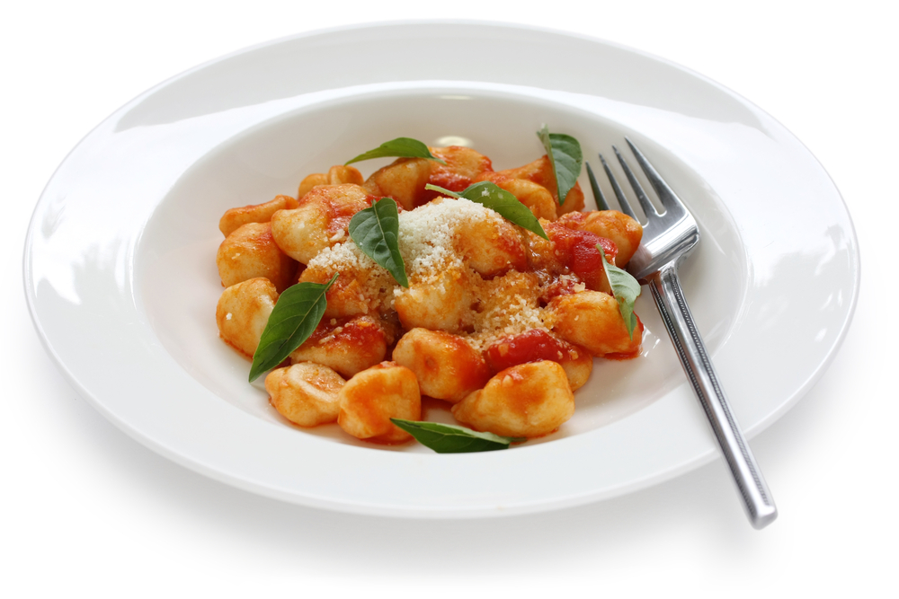
30g plain flour

1/4 small onion

1/4 celery stick

2 mushrooms

1x 400g can chopped tomatoes

1 x 5ml spoon garlic purée

1 x 10ml spoon tomato purée

1 x 10ml dried mixed herbs

Equipment
Fork, plate, knife, chopping board, potato masher, mixing bowl, flour dredger, can opener, measuring spoons, kettle, 2 microwave measuring jug, colander, serving dish, wooden spoon.

Method
- Pierce the potato with a fork and microwave on high for 5-8 minutes until soft.
(Microwave times will vary.) Allow to cool.
- Whilst the potato is cooking, prepare the vegetables for the sauce:
  - peel and chop the onion;
  - slice the celery;
  - wipe or wash the mushroom and slice.
- Cut the potato open and scoop out the flesh and mash in the bowl.
- Add the flour to make a soft dough.
- Divide the dough in half and roll each piece into a sausage shape, 2 cm thick, on a lightly floured work surface.
- Cut into 2cm long pieces, press each lightly with the back of a fork.
- Place the onion, celery, mushroom, canned tomatoes, garlic purée and tomato purée in the microwave safe measuring jug.
- Microwave the sauce on a medium heat for 3 - 4 minutes, or until the onion is soft.
- Half fill the other large microwave safe measuring jug with boiling hot water and carefully add the gnocchi.
- Microwave on medium-high for 2 minutes, until the gnocchi rise to the top.
- Drain the gnocchi and place in a serving dish.
- Pour the tomato sauce on the gnocchi in the serving dish.

Top tips
- If short of time, use a commercial tomato based pasta sauce.
- Be careful, not to overcook the gnocchi, as it can begin to fall apart.
- Serve garnished with a little parmesan cheese or a sprig of fresh basil on top with freshly cracked black pepper.

Food skills
- Weigh.
- Measure.
- Microwave.
- Cut, chop and slice.
- Stir.
- Divide.
- Form and shape.
- Drain.

