Mini ham and onion rostis
Complexity: low-medium

Ingredients

2 large waxy potatoes

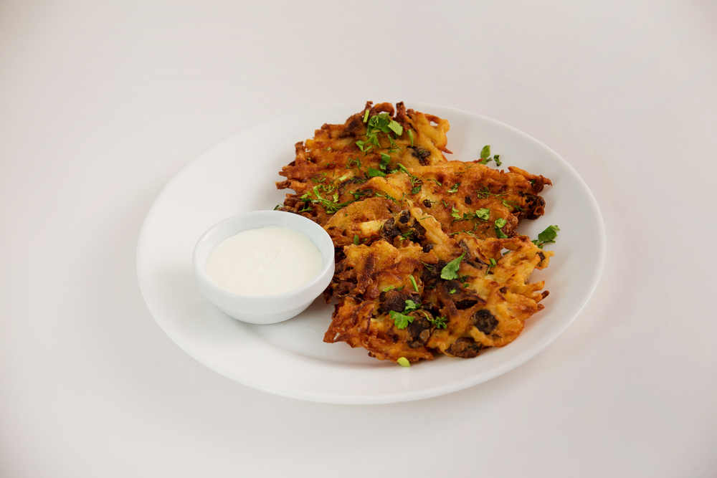
2 x slices of ham

2 spring onions

1/2 x 5ml spoon garlic purée

2 x 5ml spoon dried mixed herbs

Reduced fat crème fraiche to serve

Equipment
Baking tray, vegetable peeler, grater, chopping board, knife, mixing bowl, wooden spoon, measuring spoons, oven gloves.

Method
- Preheat oven to 180°C (375°F) or Gas mark 4.
- Grease or line the baking tray.
- Prepare the ingredients:
  - peel and grate the potato;
  - chop the ham;
  - snip or slice the spring onions.
- Add the potato, ham, onion, garlic purée and herbs to the mixing bowl.
- Mix everything together.
- Using your hands, shape into 6-8 small rostis (flat pancakes), squeezing away any excess liquid.
- Place on the baking tray and bake for 20-25 minutes, or until golden brown.

Top tips
- More vegetables can be added such as canned sweet corn or peas, peppers.
- Rosti can be fried, but baking is a healthier cooking option.

Food skills
- Weigh.
- Measure.
- Peel.
- Grate.
- Chop and slice.
- Snip.
- Mix.
- Shape.
- Bake.

