Mulligatawny soup
Complexity: medium

Ingredients

2 large waxy potatoes

1 medium onion

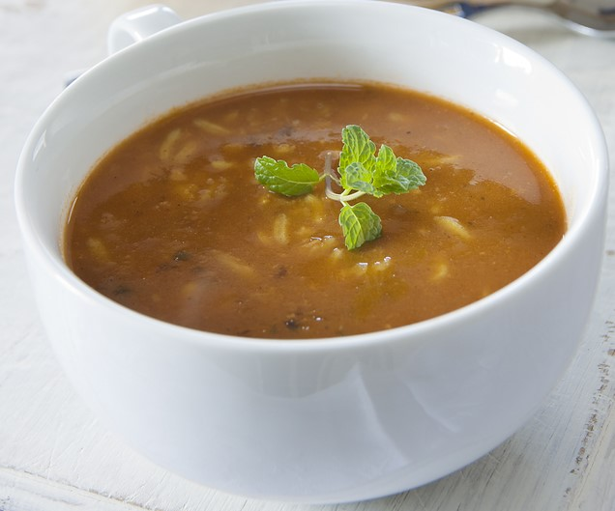
1 large carrot

1 large cooking apple

1 medium courgette

Spray oil

1 x 15ml spoon curry powder

2 x 15 ml spoons tomato purée

2 x 15ml spoons of Basmati rice

400g canned tomatoes

700ml beef stock (1 stock cube and boiling water)

Equipment
Vegetable peeler, knife, chopping board, saucepan, measuring spoons, wooden spoon, can opener, measuring jug, pot stand.

Method
- Prepare the ingredients:
  - peel and dice the potatoes;
  - peel and dice the onion;
  - peel and dice the carrot;
  - peel and dice the apple;
  - peel and dice the courgette.
- Fry the potatoes, onion, carrot, apple and courgette in a few sprays of the oil for 5 minutes.
- Stir in the curry powder, tomato purée, rice, canned tomatoes and beef stock.
- Bring to boil, cover with a lid and simmer for 20-25 minutes.

Top tips
- Soups can be garnished in a variety of ways, e.g. a sprig of parsley, or a dollop of natural yogurt.

Food skills
- Measure.
- Peel.
- Dice
- Fry.
- Stir,
- Boil and simmer.

