Kahoot guide

These are the steps to using a Kahoot quiz in the classroom.

When using Kahoot it is important to note:

- games are displayed on a shared screen, for example a smart TV, a laptop or an interactive whiteboard that all the players can see;
- players join in using their own device – whether that is a smartphone, tablet, laptop or desktop computer.

This guide will show what will come up on the main screen (images on the left of the pages) and what a player will see on their individual device (images to the right of the pages).

- Click the link of the BNF Kahoot quiz that you wish to use. This should be displayed on a shared screen – for example a smart TV or interactive whiteboard. Everyone playing will need to be able to see this screen.
- Players should search for kahoot.it on their device browser.

- You can then select a classic game or a team vs team game. This will vary on individual preference. If the class are playing on individual devices then select classic. If multiple pupils are sharing a device then select team mode.

Main screen view Individual device view
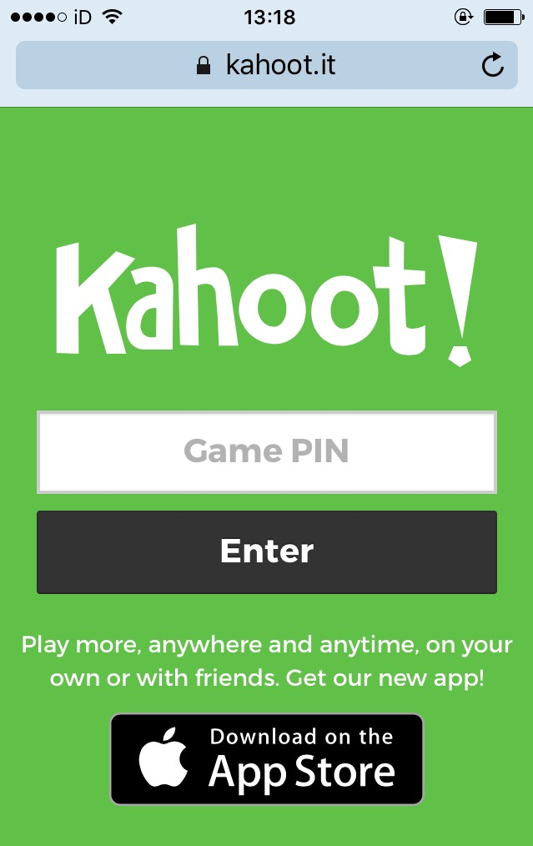
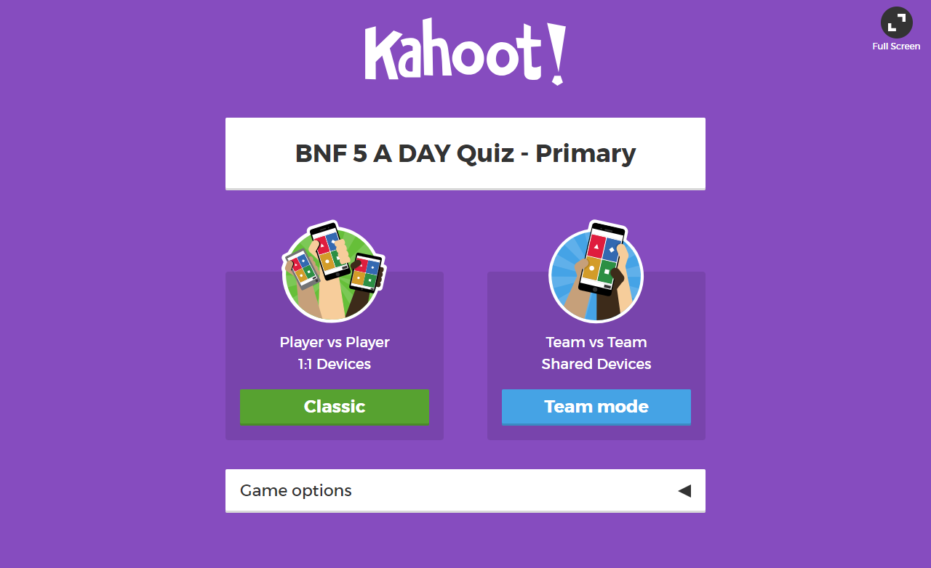

- Once a mode has been selected, a unique Game PIN will be displayed at the top of the screen. Players, on their own devices, enter this PIN to join the game. (This should be either in the Kahoot! app for iOS and Android or by going to kahoot.it in their browser.)

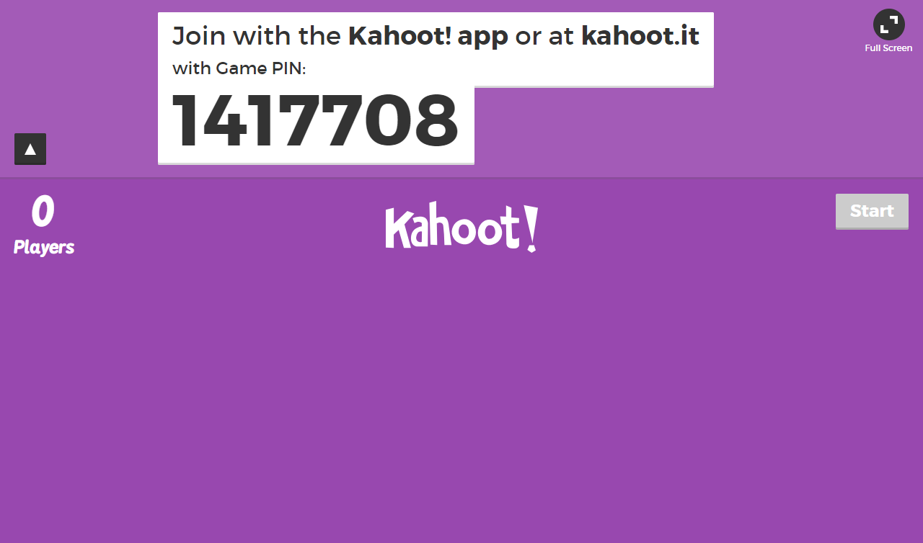

- After typing in the Game PIN the players will be asked to type in a name or nickname and these will appear on the “lobby” or waiting screen. Beware naughty nicknames! If someone uses a naughty nickname and you want to remove them, you can do this by clicking on their name on the shared screen.

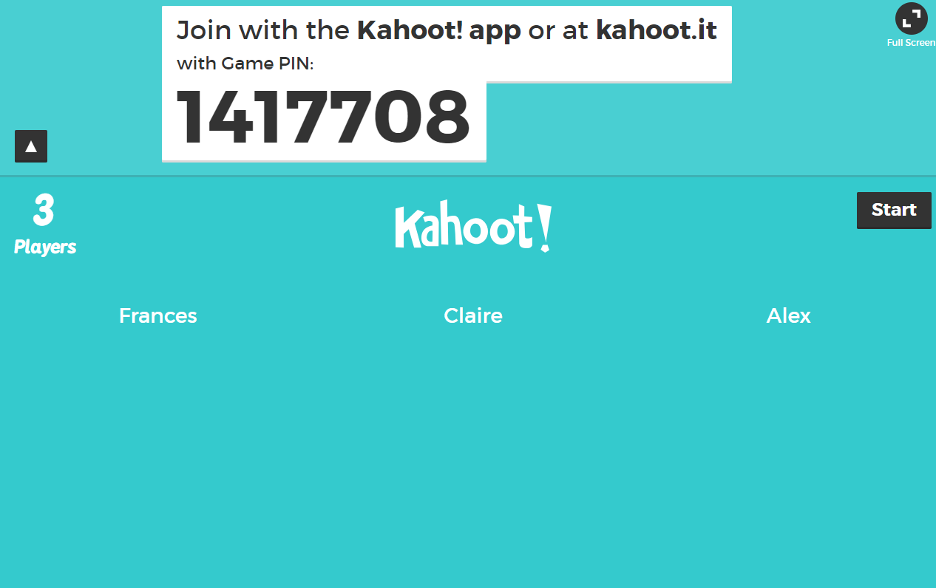
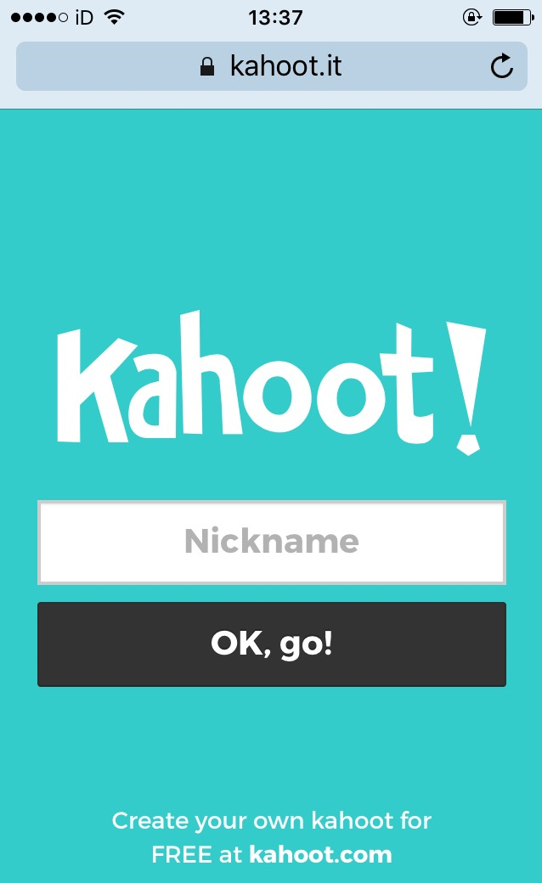

- Click Start once you can see all the players’ nicknames on the “lobby” or waiting screen.

- Each question will allow time for the players to read and answer the question. Players should click on the colour and shape on their own device which corresponds to the answer they think is correct on the main screen. Players will receive points for correct answers, how quickly they answer each question and if they get multiple answers correct in a row!
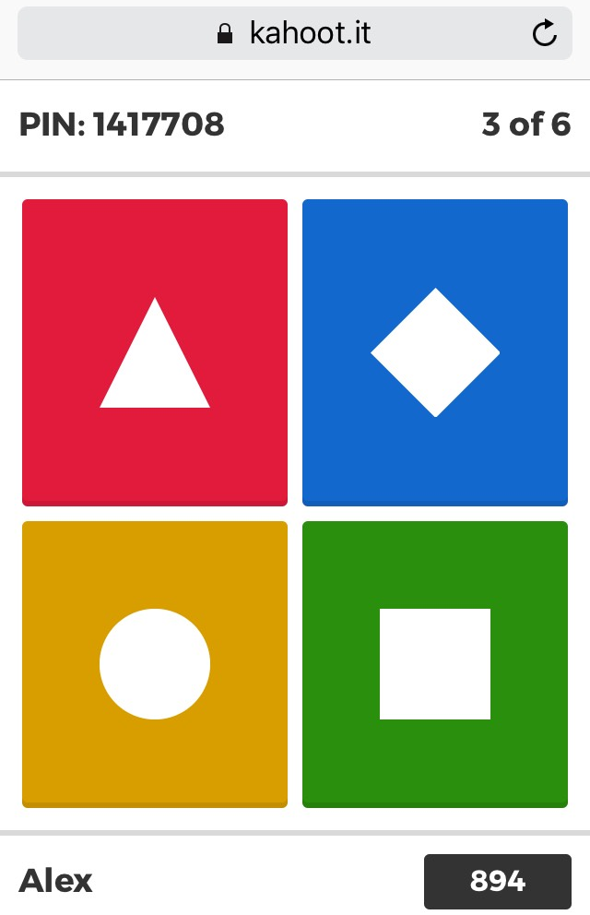
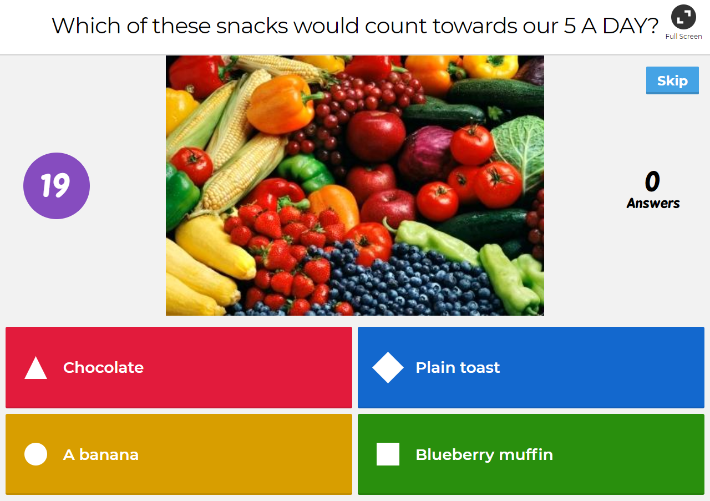

- Once everyone has answered the question the shared screen will show how many players selected each option and how many got the answer correct! When you are ready, simply click Next to move on.
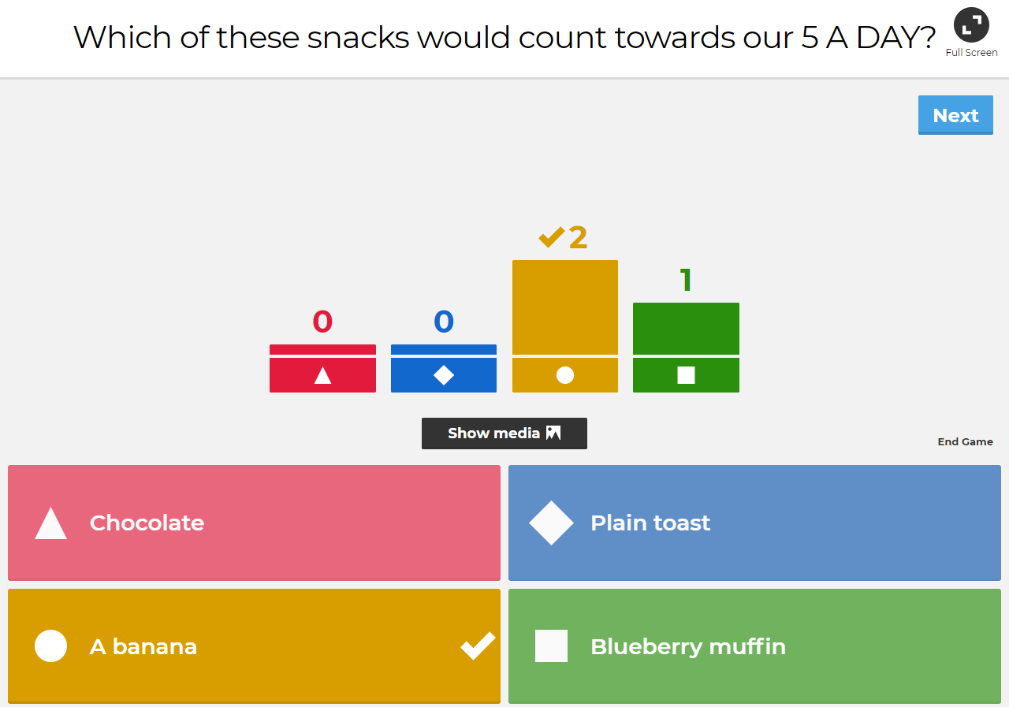
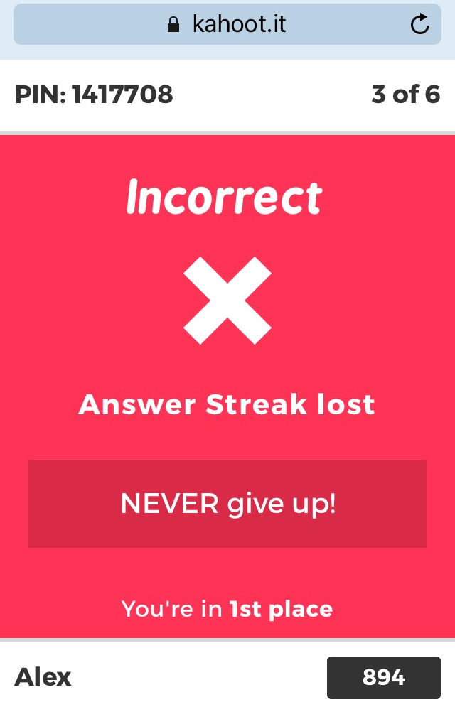

- After each question, a leader board will show on the shared screen. Players on their own device will also be told if they got the question correct or incorrect and how many points behind the closest player they are. To move to the next question, click Next on the shared screen.
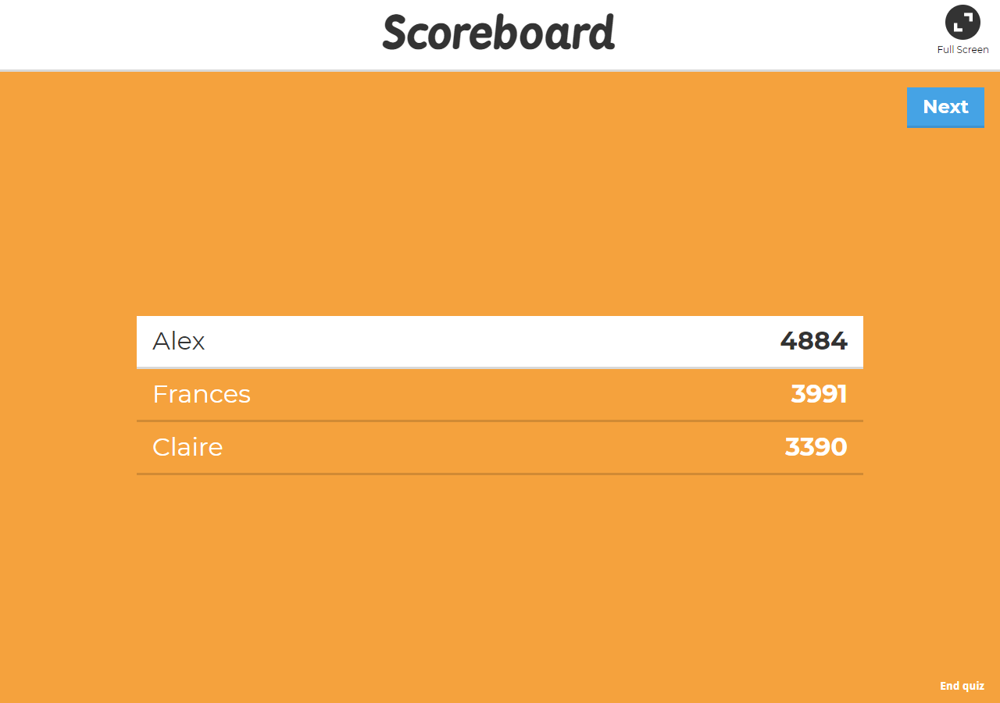
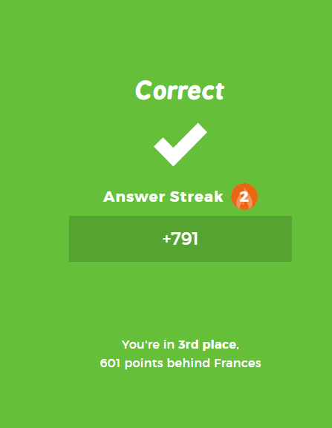

- Once all of the questions have been answered, a podium on the shared screen will show which 3 players achieved the highest scores. This depends on how many questions each player has got correct, how quickly they answer each question and if they get multiple answers correct in a row! By clicking the ‘get results’ link you can see more of the pupils’ results.
