Fruit salad
Ingredients
Complexity: low-medium
1 banana
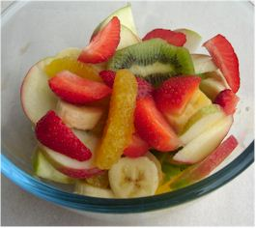
1 apple
1 orange
4 strawberries
10 grapes
1 kiwi fruit

Equipment
Chopping board, knife, mixing bowl, measuring jug.

Method
- Prepare fruit:
  - peel and slice the banana;
  - core and slice the apple;
  - peel and segment the orange;
  - halve the strawberries;
  - halve the grapes
  - peel and slice the kiwi fruit.
- Place all the fruit into a large serving dish and mix gently.

Top tips
- If you are not peeling the fruit, make sure it is washed before you use it.
- Use fresh fruit in season, like raspberries in summer or apples in autumn.
- Mix in some canned fruit like pineapple or peaches - if using canned fruit opt for those canned in natural juice instead of syrup.
- Serve with low-fat yogurt for a great breakfast or dessert.
Food skills
- Peel.
- Core.
- Slice and cut.
- Mix.

