Halloumi and vegetable skewers
Ingredients
Complexity: low-medium
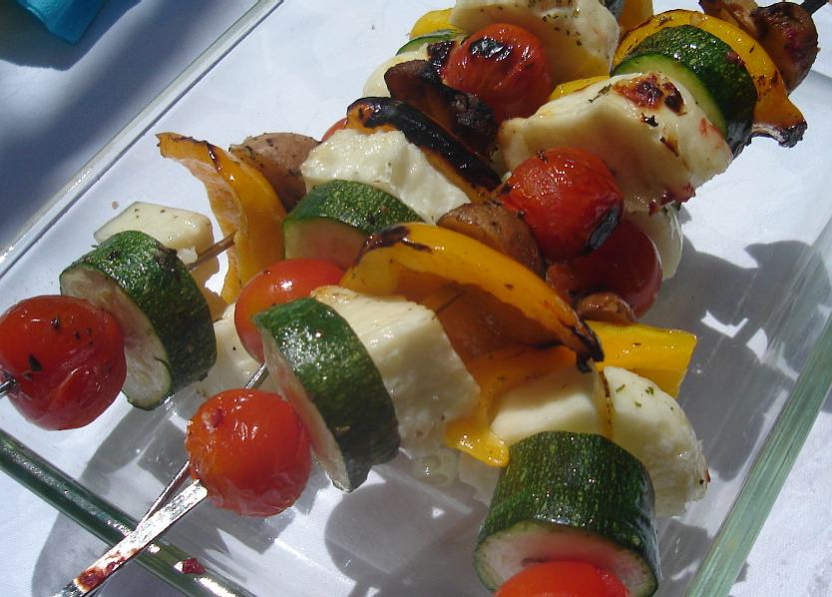
1 pack halloumi
1 courgette
5 mushrooms
1 yellow pepper
8 cherry tomatoes
Spray oil
1 garlic clove
1x5ml spoon mixed herbs

Equipment
Chopping board, knife, skewers, garlic press, pastry brush.

Method
- Cut the halloumi cheese into large cubes.
- Prepare the vegetables:
  - top, tail and thickly slice the courgettes;
  - wash and halve the mushrooms;
  - deseed and thickly slice the yellow pepper;
  - peel and crush the garlic.
- Thread the halloumi and vegetables onto kebab sticks.
- Mix a few sprays of the oil with the herbs and garlic.
- Brush the mixture over the halloumi and vegetables.
- Barbeque, grill or oven bake until brown, turning occasionally (10-15 minutes).

Top tips
- Experiment with different herbs and spices - try paprika or chilli flakes to give it a kick!
- Try different vegetables, or add some pineapple for a sweeter kebab.

Food skills
- Measure.
- Trim and slice.
- Peel.
- Crush.
- Brush.
- Grill.

