Jerk potato and black bean curry

Ingredients
Complexity: medium

1 onion

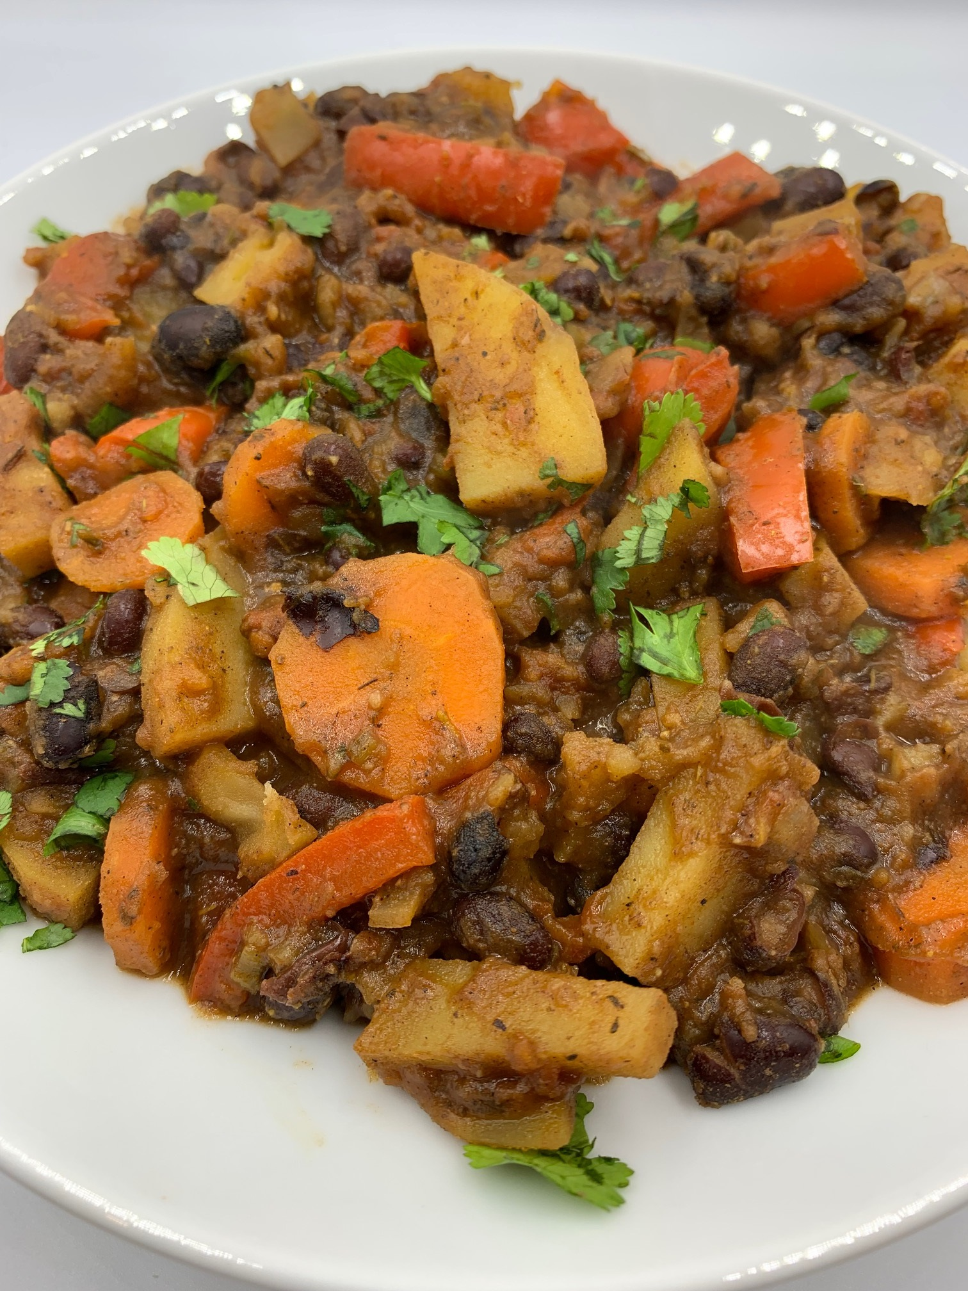
1 stick celery

1 small or ½ large carrot

½ small green chilli

1 red pepper

3cm piece root ginger

400g can black beans

350g potatoes

1 x 15ml spoon fresh coriander

Spray oil

1½ x 15ml spoons jerk seasoning

1 x 5ml spoon dried thyme

1 reduced salt vegetable stock cube

250ml boiling water

1 small can (227g) chopped tomatoes

Black pepper

Optional

Reduced fat sour cream or yogurt to serve

Equipment

Chopping board, vegetable knife, vegetable peeler, grater, sieve/colander, large saucepan, mixing spoon, measuring spoon.

Method
- Prepare the ingredients:
- peel and chop the onion;
- chop the celery;
- peel and slice the carrot;
- deseed and finely chop the chilli;
- deseed and slice the red pepper;
- peel and grate the ginger;
- drain and rinse the beans;
- peel the potatoes and cut into chunks;
- chop the coriander.
- Add spray oil to a large saucepan and heat. Add the onion, celery, carrot and chilli and cook for 5 minutes until soft.
- Add the jerk seasoning, potatoes, thyme, ginger and red peppers and stir well.
- Continue frying for a further 2 minutes.
- Crumble the stock cube into the pan and add 250ml boiling water. Stir well.
- Add the beans and canned tomatoes. Bring to the boil, reduce the heat and simmer for 15-20 minutes, until the vegetables are cooked.
- Season with black pepper.
- Just before serving stir in the coriander.
- Serve with reduced fat sour cream or yogurt (optional).

Top tips
- Make your own jerk seasoning using a blend of ground cinnamon, black peppercorns, dried thyme, allspice berries, cayenne pepper and nutmeg. Toast the whole spices, add the ground spices and herbs and crush to a fine powder.
- When preparing chilli peppers, do not to touch the eyes or similar areas that can be affected by the capsaicin (an irritant) that rubs off on hands. Wash your hands immediately after handling chilli peppers.
To prepare remove the stem and slice the chilli pepper in half. With a teaspoon, carefully remove the ribs and seeds then slice or dice as needed.

Food skills
- Weigh
- Measure
- Peel
- Cut
- Chop
- Slice
- Drain
- Boil
- Simmer
- Stir

Did you know?
Jerk refers to a way that ingredients, such as chicken, beef, pork, goat, fish, vegetables or fruit are seasoned and cooked. The typical cooking style uses a marinade that includes pimento, which is often called allspice, and scotch bonnet peppers, also known as habenero. The ingredient is then marinated and slow smoked over pimento wood. Pimentia or pimento is a Spanish word for pepper and early European explorers mistook this for black pepper, so they called it pimento.

Two types of jerk seasoning, powder and paste, are available commercially in mild and spicy varieties. Jerk paste acts as a marinade, allowing the flavours, which intensify during smoking, to penetrate the meat.

