Information

These cards show the energy provided by 100g of each food. The energy is shown is kilojoules (kJ) and kilocalories (kcal).

The cards also show a serving size range for children aged 7-10 years. These have been taken from this summary of food portion sizes suitable for 4-18-year-olds.
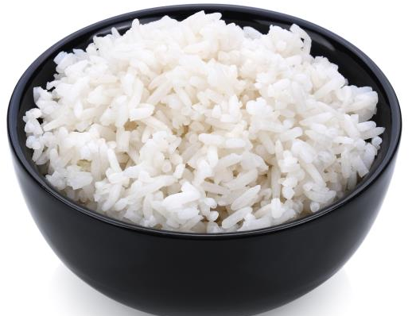

100g = 498kJ / 117kcals

White rice (boiled)

(serving size: 84–174g)

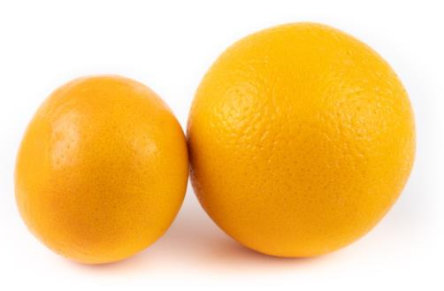
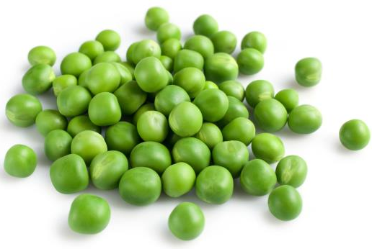

100g = 152kJ / 36kcals
100g = 329kJ / 79kcals

Orange

(serving size: 70–145g)

Peas (boiled)

(serving size: 42–87g)

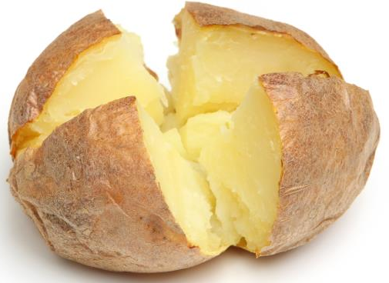
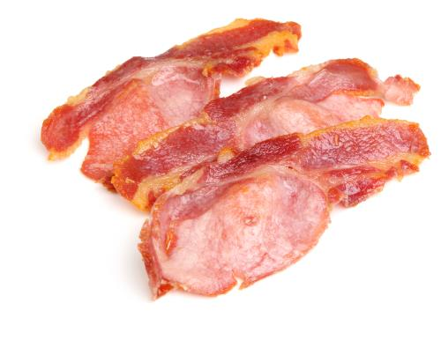
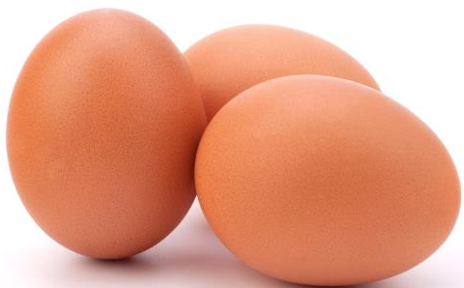
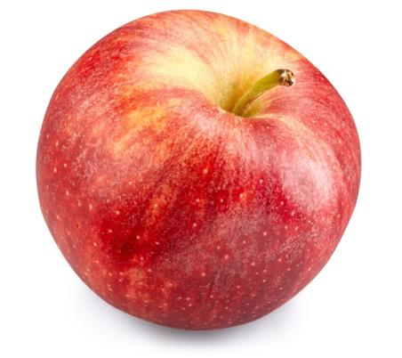
Baked potato

(serving size: 70–145g)

100g = 221kJ / 52kcals
Boiled eggs

(serving size: 42–87g)

100g = 329kJ / 77kcals
100g = 1216kJ / 293kcals
Bacon (grilled)

(serving size: 25–51g)

100g = 183kJ / 43kcals
Apple

(serving size: 70–145g)
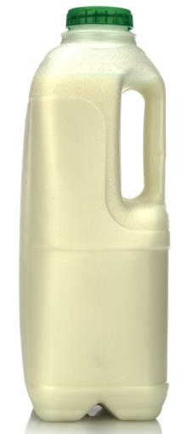

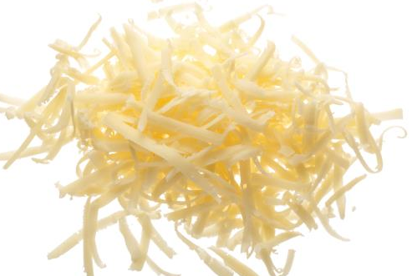

100g = 1725kJ / 416kcals
100g = 195kJ / 46kcals

Cheese

(serving size: 21–44g)

Milk (semi skimmed)

(serving size: 112–232g)

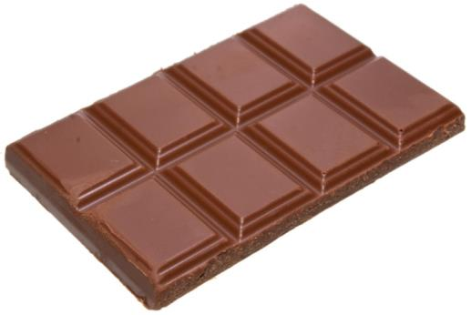
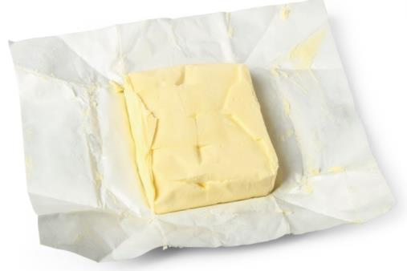

100g = 2171kJ / 519kcals
100g = 3059kJ / 744kcals
Butter

(serving size: 7–15g)

Milk chocolate

(serving size: 25–51g)

(serving size: 112–232g)

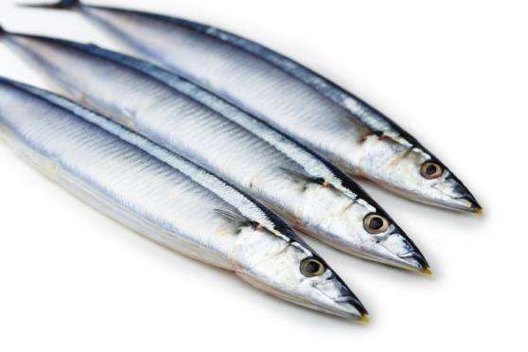
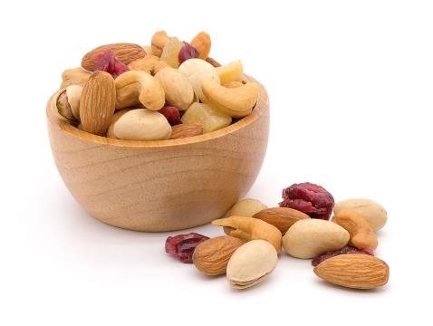

100g = 1174kJ / 283kcals
100g = 2407kJ / 581kcals

Mackerel (grilled)

(serving size: 42–87g)

Mixed nuts

(serving size: 25–51g)

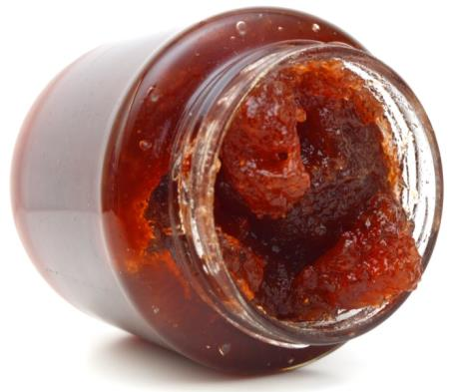

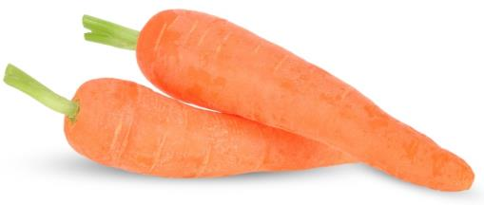

100g = 1114kJ / 261kcals
100g = 146kJ / 34kcals
Carrots (raw)

(serving size: 28–58g)

Jam

(serving size: 8–17g)

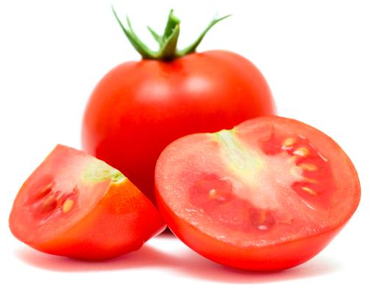
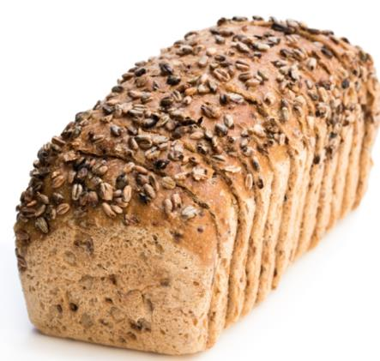

100g = 882kJ / 207kcals
100g = 61kJ / 14kcals
Wholemeal Bread

(serving size: 50–104g)

Tomato

(serving size: 32–65g)

(serving size: 84–174g)

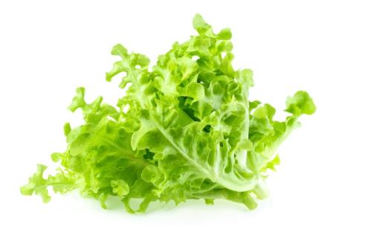
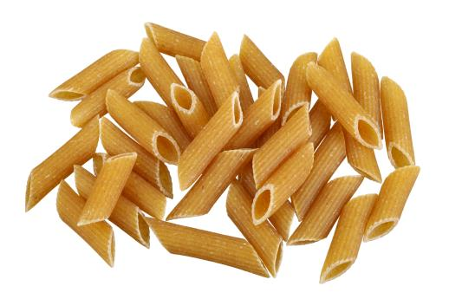

100g = 718kJ / 169kcals
100g = 48kJ / 11kcals

Lettuce

(serving size: 32–65g)

Pasta (boiled)

(serving size: 84–174g)

