Testing food for starch

Introduction
This is a simple test which shows whether food contains starch. When iodine solution is mixed with starch it turns from brown to dark blue. As this happens with very small amounts of starch, iodine test is a sensitive one. Starch forms as grains inside the living cells of plants.

Iodine solution penetrates into the starch most easily when the cell walls have been destroyed and it reacts most readily when the starch grains are swollen. Both these things happen when food from plants is cooked.

You will need
Equipment
Test tubes
Test tube rack
Glass rod
Spatula
Mechanical grinder or pestle and mortar
Dropping pipette
White tile
Eye protection

Materials
Food samples, fresh and cooked
Iodine in potassium iodine solution
Distilled water
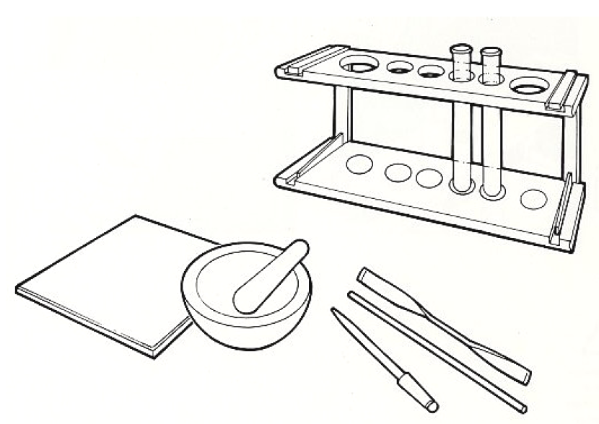





Some people are allergic or intolerant to a particular food or ingredient. Refer to the 14 allergens and check against student records before completing this experiment.

Do not consume food in a laboratory, or any food used for experiments, because it may contaminated.
Wear eye protection.
Iodine solution should be handled with care. Take care to avoid unpleasant staining of hands and materials.

Method

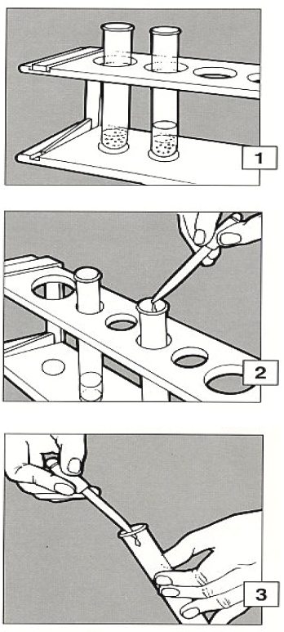
- If the food to be tested is liquid, go to 2. If the food to be tested is solid, make an extract. Grind crush or chop a small amount and put into a test tube to a depth of about 2cm. Add a similar amount of distilled water and stir with a glass rod. Allow to stand for a few minutes.

- Draw up some of the clear liquid into a pipette and then either transfer it into another test tube or put drops onto a white tile.

- Add on drop of (brown) iodine solution on the tile and look for a colour change.

A blue-black colour indicates the presence of starch.

Extension work
It is possible to see where exactly in a plant the starch is situated. For example, a seed, which has been thoroughly soaked to make it soft, can be cut into a very thin slice and treated with iodine solution.

Examination with powerful lens or low-power microscope will reveal the position of starch, coloured dark blue by iodine.

More information can be obtained by adding Schultze solution instead of iodine.
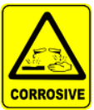
Seen under the microscope after adding Schultze’s solution.
Thin cell walls (made of cellulose) appear – violet
Schultze’s solution is corrosive and harmful. Wear gloves.
Thick (wood) cells – yellow
Protein – brown
Wear eye protection.
Starch – blue

