Custard making activity

In this activity, you will be making and comparing three different custard recipes. As you make and taste each recipe, consider the following questions and then complete the custard making and tasting chart.
- How long did it take to make?
- How does it look, smell and taste?
- How thick is the custard? Use the Viscosity chart to test this.
- What are the advantages and disadvantages of each of the recipes/methods?
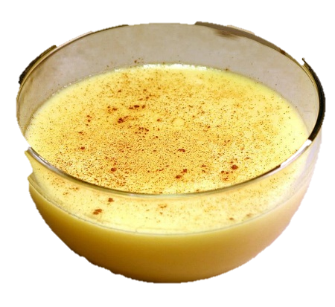
- Egg custard
Ingredients
2 eggs
2 x 5ml spoon caster sugar
300ml milk
1 x 5ml spoon vanilla essence (optional)

Equipment
Large mixing bowl, fork, wooden spoon, saucepan, digital thermometer, double saucepan or glass mixing bowl

Method
- Crack the eggs into a large mixing bowl. Wash and dry hands thoroughly after touching the eggs.
- Add the sugar and beat lightly with a fork (enough to mix yolk and white, but not enough to incorporate air).
- Heat milk to 37°C and pour onto beaten mixture, stirring well.
- Heat gently, preferably in a double pan (you can use a glass bowl over hot water instead) or over a low heat, stirring well until sauce thickens. Do not boil. Gentle heating causes even coagulation of egg proteins and thickening of sauce. Boiling causes curdling.
- If the custard curdles a little, try removing it from the heat, adding 1 x 5ml spoon of iced water and beating well. This will prevent further curdling, but will not make as smooth a sauce.

- Custard made with powder
Ingredients
1 x 15ml spoon custard powder
1/2 x 15ml spoon sugar
250ml semi-skimmed milk

Equipment
Mixing bowl or measuring jug, spoon, saucepan, wooden spoon

Method
- Put the custard powder and sugar in a bowl or measuring jug.
- Mix into a smooth paste with a little (approx. 1 x 15ml) milk taken from the 250ml.
- Heat the remaining milk to nearly boiling and pour onto custard mix, stirring well.
- Return to the saucepan and bring to the boil over a gentle heat, stirring continuously. Stirring ensures even heating and the starch granules absorb liquid and swell, thickening the liquid to produce a smooth, thick sauce. Cook well to avoid a raw taste.
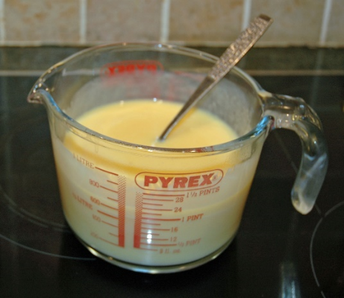
- Instant custard
Ingredients
1 packet instant custard (requiring only boiling water)

Equipment
Measuring jug, spoon

Method
- Pour the instant custard powder into a measuring jug.
- Boil kettle and add the required amount to the custard powder.
- Stir and serve.

Food such as instant custards or other ‘just add water’ products contain modified starches which enable them to be made quickly. They can also be stored at ambient (room) temperatures for long periods of time. For more information about modified starches, you can refer to the Modified starch information sheet.

Custard making and tasting
Custard | Ingredients | Thickening process | Viscosity recording | Time taken and ease of making | Taste | Texture | Smell | Appearance

Explain the conclusions that can you draw from the results.

