World food labels
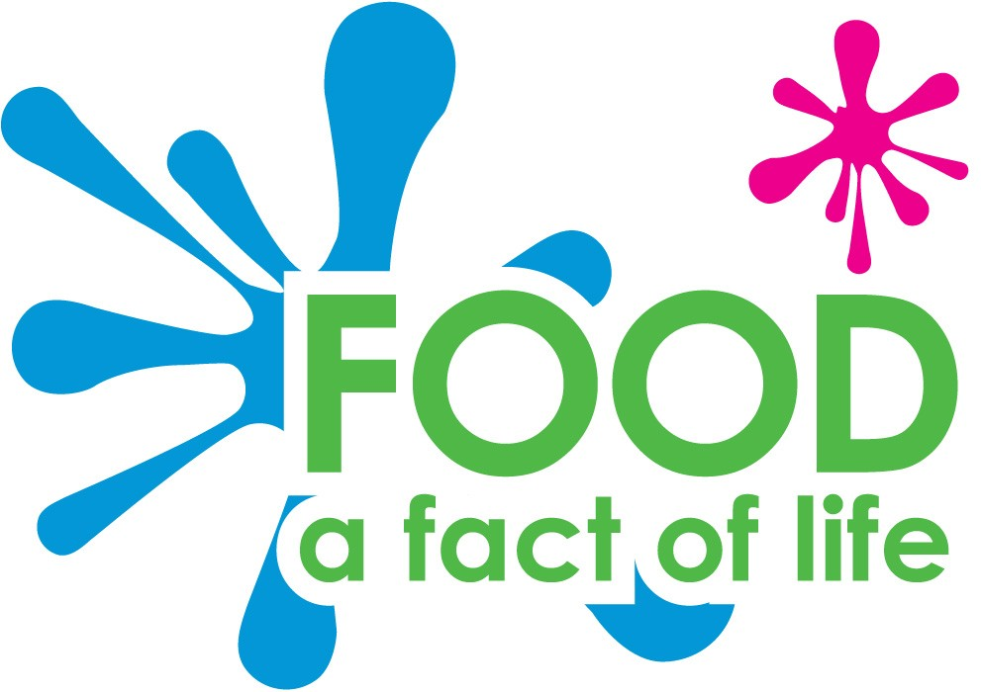
Rice
India
Lemon
Argentina

Buffalo
Mozzarella
Italy
Plantain
Africa

Coconut
Malaysia
Coffee beans
Brazil

Bananas
Dominican
Republic
Avocado
Peru

Mango
Philippines
Watermelon
China

