Apprentice Food Technologist

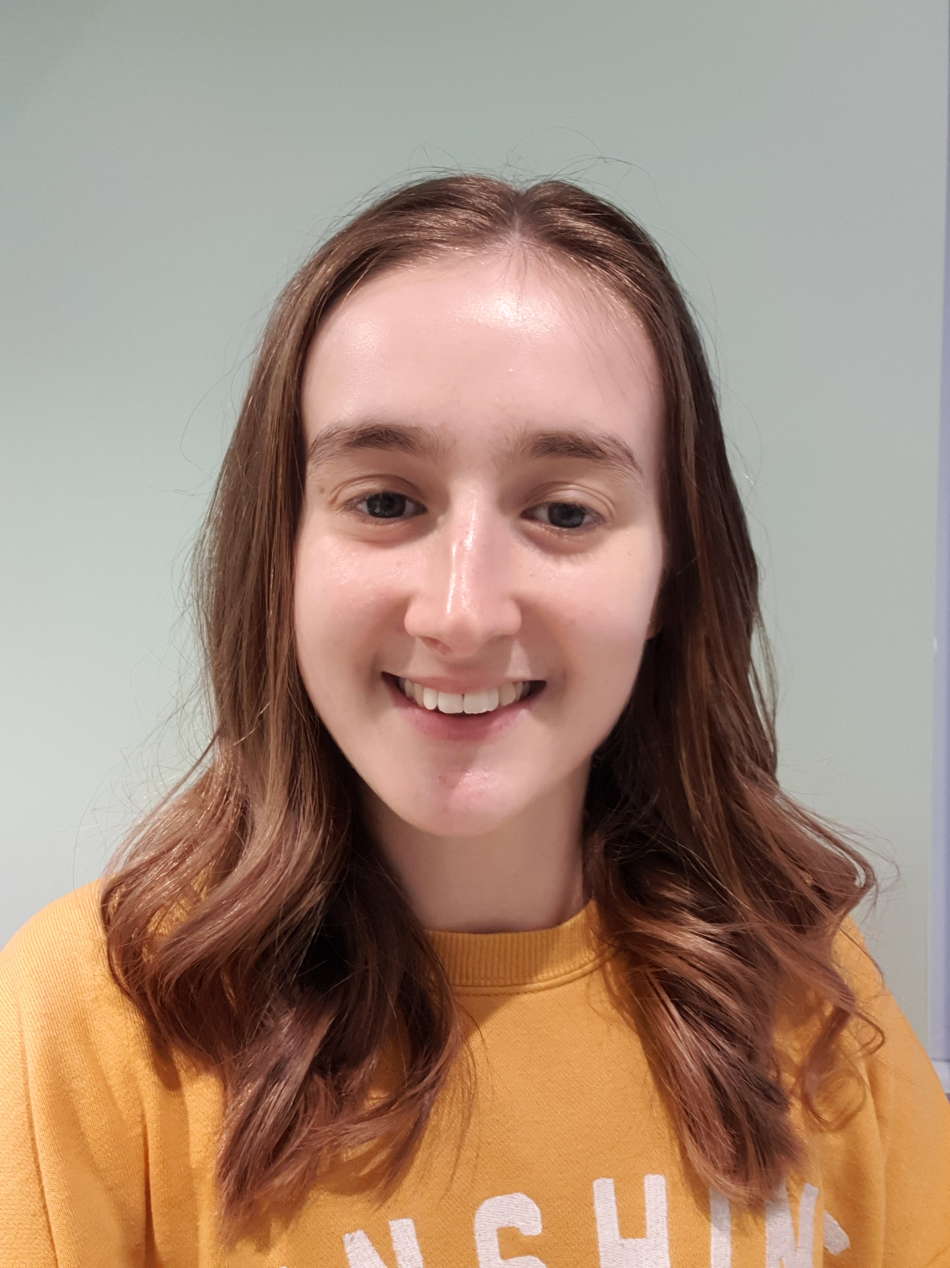
Kate Rose, Mondelez International

What qualifications do you have?

GCSE- Food and Nutrition

Level 3 Diploma (Apprenticeship)- Food Science and Technology

Food Science & Technology Degree (Apprenticeship)- Undertaking currently

What does your job involve?
My role as a product developer involves being hands on in the pilot plant (small scale factory) creating samples of new concepts and ideas and completing scientific tests to understand chocolate more- the way it behaves and works. It also involves more desk-based work reading research papers on different topics, developing recipes, and ordering and researching ingredients.

What, or who, inspired you to take your chosen career pathway?
Being honest, it wasn’t until other plans fell through at school with GCSE options (not being able to do my chosen subjects) and my work experience placement not being as enjoyable as hoped, that I considered a career in food more seriously. I am a keen baker in my spare time and decided that as I really enjoyed reading about food and watching people cook and bake and hearing about different food, I would explore what working in the food industry might look like for me.

What route did you take from leaving school to your current job?

I didn’t do A-levels as no-where offered all 3 A-levels I was interested in doing. So rather than picking subjects I didn’t enjoy (because you don’t work as hard at them!), I decided to just focus on the one I enjoyed the most at the time- food/baking. I went to UCB and completed a year (out of 2) of a Level 2 Professional Bakery course before being offered a role with Mondelez International as a “Chocolate Apprentice” whist undertaking the Level 3 Diploma part time. Once I’d completed the Level 3 diploma, I was offered the opportunity to stay on and complete a Level 6 degree apprenticeship whilst continuing to work.

What is the key knowledge, skills and experience needed for your job?
Being an apprentice is all about learning on the job, so no prior experience is needed but the sciences or food science qualifications are looked for in applications.
The skills needed include: technical curiosity, creativity, and the ability to use your science knowledge to come up with solutions.
Having knowledge of ingredients and process interactions and an understanding of the consumer is also important but as an apprentice, a keenness to learn and ask questions is fundamental.

What is the best thing about your job?
The best thing about my job is getting to learn and understand the science behind why foods (especially chocolate and confectionary in my case) behave the way they do and how changes in recipes, ingredients, processes cause different outcomes. Its also great as an apprentice to get to see what I learn in the classroom, come to life in the workplace.

What questions are you often asked about your job?
Is it hard managing your university studies and work commitments? An apprentice is legally entitled to 20% of their job time to work on university work which helps a lot with the time management. You also have to be organised to balance the university and work needs- and yes, you may have to work in your own time too!
How much chocolate do you get to eat? Between the organised sensory tests and trying your prototype samples and new products, there’s always plenty of chocolate around!
What’s the balance between practical and desk based? It depends exactly on the role and what projects you’re on but for a product developer role, it balance is about 60/40 desk/practical but for a pilot plant technician (where I first started), its more 20/80 desk/practical which is great experience to have!

What advice would you offer to someone interested in doing what you do?
- Be genuinely interested in learning and gaining knowledge and asking questions- research is all about asking questions and finding out.
- Apprenticeships are a great way to start your career if you’re more of a practical learner as you can learn on the job whilst earning! Don’t assume that university is the only way to get into a science or food career.

