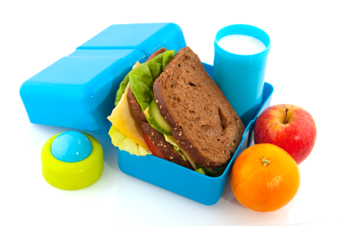
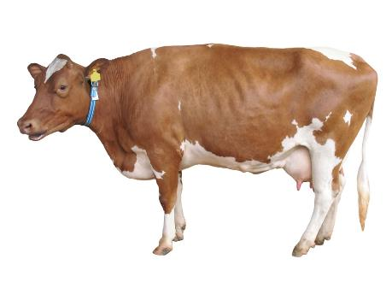
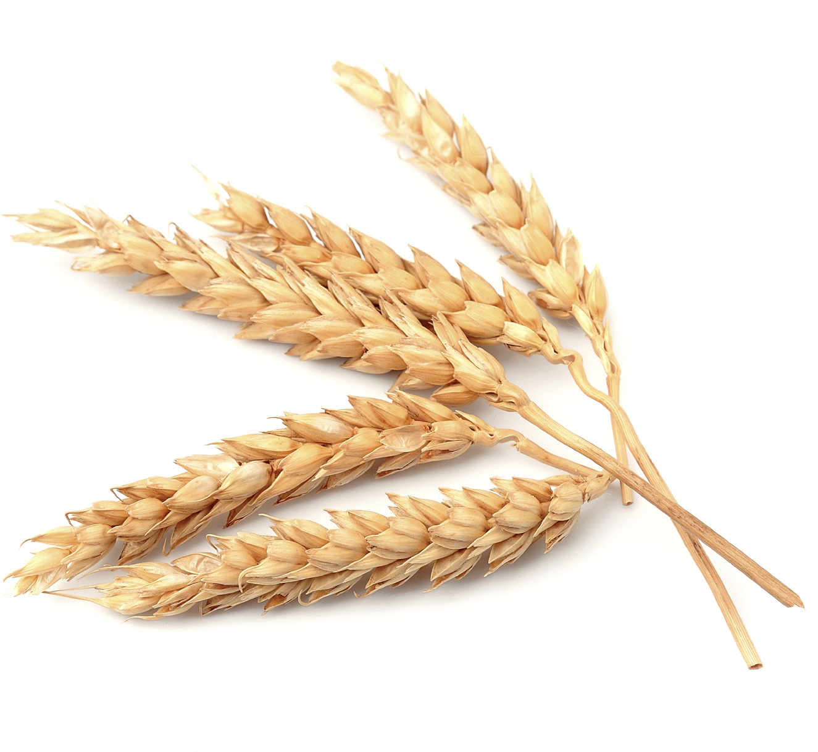
www.foodafactoflife.org.uk
© Food – a fact of life 2018
[Date]
Completing the Life on the farm Challenge
[Name]

