Vegetable soup

Complexity: medium

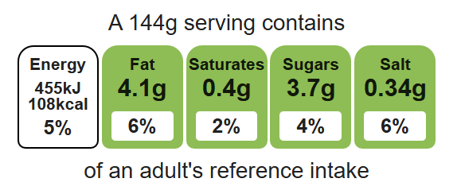

Ingredients (serves 3)

1 onion

Equipment

Chopping board

Sharp knife

Vegetable peeler

Measuring spoons

Saucepan

Measuring jug

Blender (optional)

1 carrot

1 leek

1 potato

1 celery stick

1x 15ml spoon oil or spray oil

1 reduced-salt stock cube

600ml water

1 x 15ml spoon coriander

Black pepper
Top tips
- Turn up the flavour: Swap the white potato for a sweet potato.
- Beat the budget: Use seasonal frozen or canned vegetables to reduce the cost.
- Focus on fibre: Add a can of beans, peas or lentils to increase the fibre content.
- Reduce food waste: Add any vegetables which need using up.
- If you have a blender, blend the soup to a smooth consistency

Method
- Prepare the vegetables:
- peel and chop the onion;
- top and tail, peel and dice the carrot;
- top and tail, and slice the leek;
- peel and cube the potato;
- slice the celery;
- chop the coriander.
- Fry the onion, carrot, leek and celery in the oil until soft, about 5 minutes.
- Add the potatoes.
- Add the water and stock cube to the saucepan and bring to the boil.
- Simmer for 20 minutes until all vegetables are soft.
- Stir in the chopped coriander and serve.

Food skills
Weigh and measure, peel, cut, chop, slice, dice and trim, fry and sauté, melt, simmer and boil, blitz, puree and blend.

