Herby veggie crumble

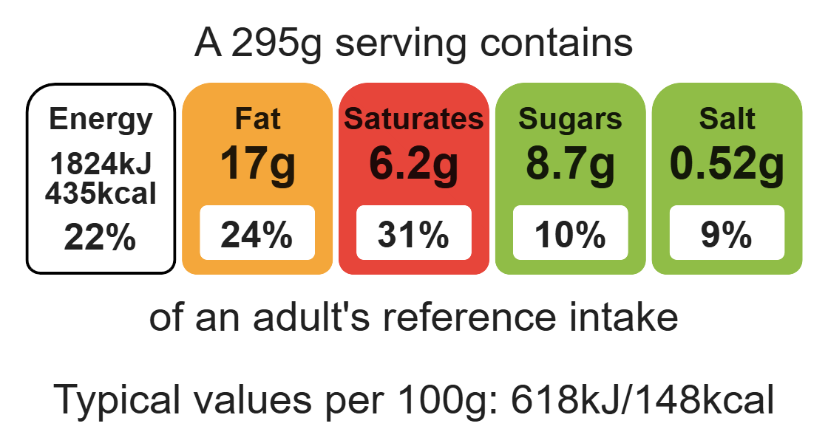
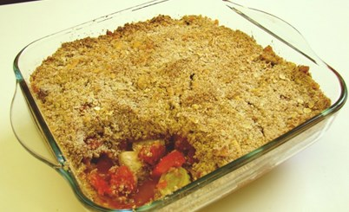

Ingredients (serves 3)

40g baking fat/block
Complexity: low - medium

150g wholemeal flour

50g reduced-fat cheese

Equipment

Weighing scales

Mixing bowl

Grater

Heat-reistant spoon

Chopping board

Sharp knife

Baking dish

Can opener

50g oats

2 x 5ml mixed herbs

2 leeks

1 pepper

4 mushrooms

1 can chopped tomatoes (400g)

Method
- Preheat oven to 200°C or gas mark 6.
- Rub the fat into the flour using your fingertips until it resembles breadcrumbs.
- Grate the cheese.
- Stir in the grated cheese, oats and 1 x 5ml mixed herbs.
- Prepare the crumble filling:
- slice the leeks and pepper;
- quarter the mushrooms.
- Arrange the vegetables in a baking dish.
- Pour over the canned tomatoes and 1 x 5ml spoon mixed herbs.
- Sprinkle the crumble topping over the vegetables.
- Bake in the oven for 25 – 30 minutes, until golden.

Top tips
- Reduce food waste: Use up any leftover vegetables such as sweetcorn, broccoli, courgette.
- Turn up the flavour: Use different herbs to vary the flavour e.g. parsley or thyme. You can be creative with your crumble topping. Try different types of cheese e.g. parmesan or feta.
- Serving suggestion: Serve the crumble with a side salad.

Food skills
Weigh, measure, rub-in, grate. Mix, stir and combine, cut, chop, slice, dice and trim, bake.

