Perfect lunch!

Plan the perfect lunch. Draw and label your ideas below.

This lunch is for ________________________________ .

They don’t eat _______________________________________ .

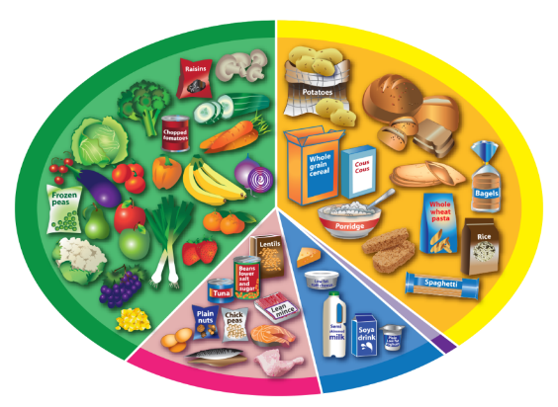

Remember!
A healthy lunch should include foods from the four main Eatwell Guide food groups and a drink!
Does yours?

