Sustainable healthy diets pick and mix
Try these sustainable healthy diets activities from this pick and mix selection!
  Research and compare three different protein sources (e.g. lentils, tofu, chickpeas, meat, poultry, fish) in terms of nutritional value (protein, vitamins, etc.) and environmental impact.  Give five examples of dishes where they can be used.  Make, taste and evaluate a dish made with one of the protein sources. |   Interview a family member and reflect on your own family’s food traditions.  Identify one traditional food practice (e.g. family meals, preserving food or growing ingredients) and suggest three ways to make it more sustainable. |   Choose three packaged snacks you usually eat and research their ingredients and sources, and the amount and type of packaging. Suggest an eco-friendly alternative you could choose, explaining why it is more sustainable.  Extra challenge: Make a sustainable version of your favourite snack. |   Plan a balanced, sustainable meal for your family, considering factors like protein sources, seasonal produce, and minimal food packaging.  Calculate the approximate cost of the meal. Is it ‘budget-friendly’ (around £1 per person is often considered ‘budget-friendly’)?  Are there any changes you could make to reduce the cost?
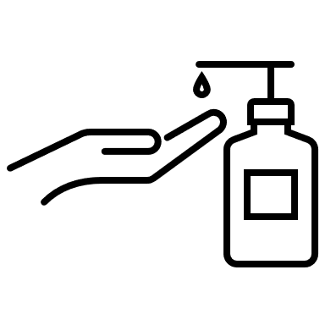  Create a short video (1-3 minutes) explaining why good food hygiene is essential in sustainable food production. Include the risks of poor hygiene and how good hygiene protects consumers and supports sustainable practices.  Extra challenge: Include one example of a foodborne illness outbreak caused by poor hygiene practices and how it impacted the environment or the food industry. |   Research a person, chef, company, or organisation focused on sustainable or ethical food practices.  Create a hero profile based on your research. Describe the actions they are taking for a more sustainable food system. Reflect on why your chosen “hero” is inspiring and how their work makes a difference. |   Research why eating 5 A DAY is recommended.  Explain why it’s important to choose sustainable fruit and vegetables, including at least three tips for how to make more sustainable choices.  Create a one-day plan showing how you can eat five portions of fruit and vegetables sustainably. For each portion, explain why it is a sustainable choice. | 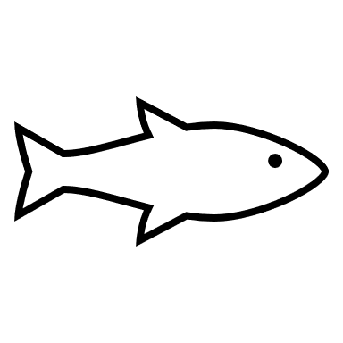  We should eat two portions of fish a week.  Research five types of seafood commonly eaten in the UK.  Find out if they are sustainably sourced identifying any certifications or labels that indicate they are sustainable.  Explain how certifications help protect fish stocks and marine environments.

