Shortbread

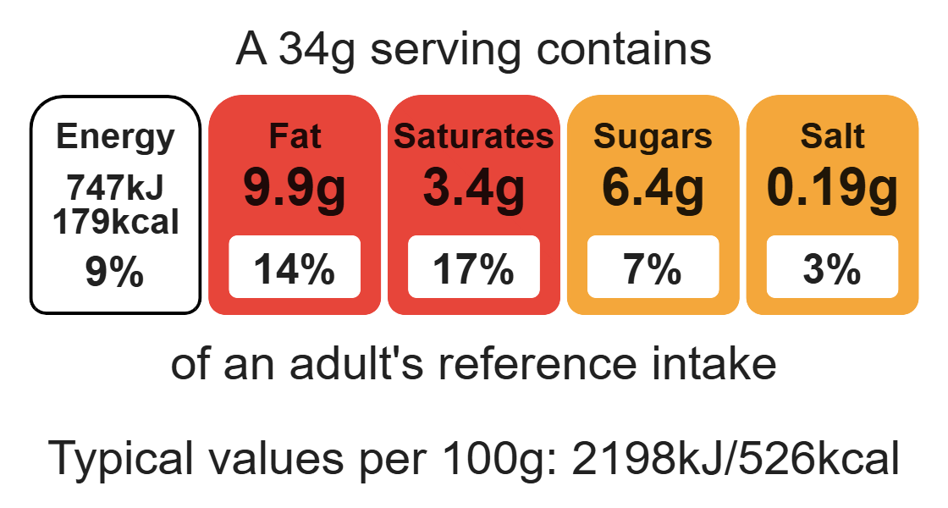
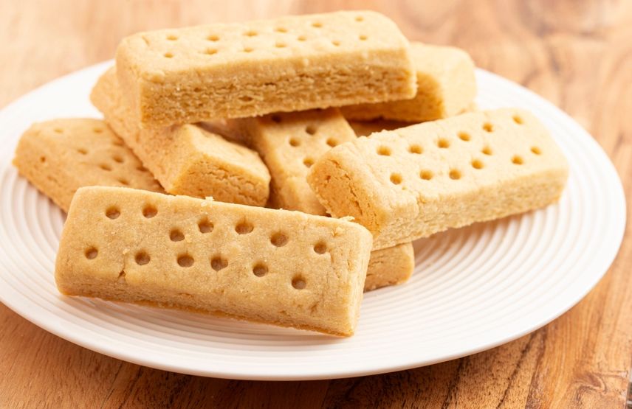

Ingredients (makes 8)

150g plain flour
Complexity: low - medium

100g baking fat/block

50g caster sugar

Equipment

Baking tray

Weighing scales

Mixing bowl

Flour dredger (optional)

Rolling pin

Palette knife

Sharp knife

Fork

Cooling rack

Method
- Preheat the oven to 170°C or gas mark 3.
- Line the baking tray with greaseproof paper.
- Place the flour, sugar and fat into the mixing bowl.
- Rub together firmly using your fingertips until the mixture forms a ball.
- Place the dough on a floured work surface and roll out the shortbread until it is 1.5cm thick and in a square shape.
- Cut into shortbread 8 fingers and place onto the baking tray.
- Wearing oven gloves, place the baking tray into a hot oven.
- Bake the shortbread for 10 - 12 minutes, until golden brown.
- Remove the shortbread from the oven. Allow to cool and then place onto a cooling rack.

Top tips
- Reduce food waste: Use up any leftover fruit dried fruit such as sultanas.
- Turn up the flavour: Try adding ½ x 5ml spoon cinnamon or nutmeg or the zest of lemon, lime or orange to enhance the flavour.
- Use cutters to make different shapes for the shortbread biscuits.

Food skills
Weigh, rub-in, roll out, form and shape, bake.

