Picturesque pizza
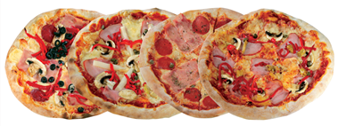
Ingredients
2 x English muffins
Complexity: low-medium
4 x 15ml spoons of a tomato sauce*
1 x orange pepper, halved and deseeded
2 x spring onions
2 x 15ml spoons sweetcorn (canned)
1 handful of basil leaves
60g Cheddar cheese, grated

Equipment
Bread knife – for adult use only, chopping board, 15ml spoon, table knife, kitchen scissors, grater, baking tray, oven gloves, 4 x serving plates.

Method
- Pre-heat the oven to 200C/gas mark 6.
- Cut the two muffins in half and rest them on the chopping board. These will be the pizza bases.
- Add a 15ml spoon of sauce to each pizza base. Spread it evenly over the base with the table knife.
- Use the scissors to cut the pepper into strips. Cut each strip into small pieces and arrange it over the four pizza bases.
- Snip the spring onions into small pieces and add to the bases.
- Add some sweetcorn to each.
- Tear the basil leaves and arrange on top.
- Sprinkle the cheese over the four pizzas.
- Place the pizzas on the baking tray. Adult - Use oven gloves to place the baking tray in the oven.
- Cook for a 7-10 minutes until the cheese bubbles and browns.
- Adult - Remove from the oven using the oven gloves and serve.

Top tips
- Try different vegetable toppings such as sliced mushrooms, chopped cherry tomatoes, sliced courgettes, canned tuna or cooked ham.
- Try different bread such, as slices of baguette, thins, pitta or crumpets.
- Serve with a colorful salad.

Food skills
- Cut.
- Spread.
- Snip.
- Bake.

*Tomato sauce – check product labels and select one with the lowest fat, sugars and salt.

