Delicious dip
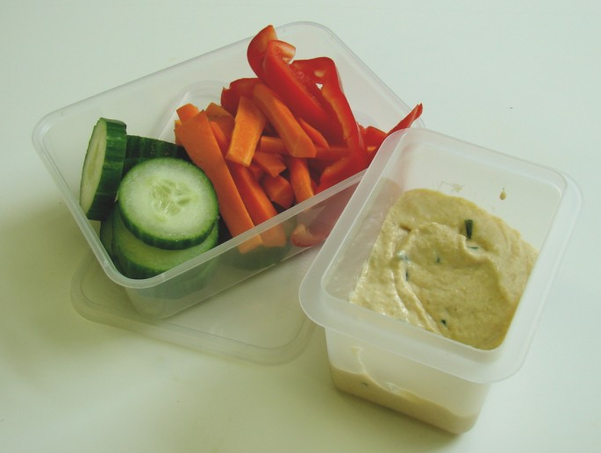
Ingredients
4 x 15ml spoons reduced fat hummus
Complexity: low
2 x 15ml spoons reduced fat plain yogurt
Small bunch of chives
A selection of vegetable dippers, e.g. baby corn, sugar snap peas, carrot batons, pepper sticks, celery sticks

Equipment
15ml spoon, mixing bowl, a kitchen scissors, mixing spoon, small serving bowl, small serving plate.

Method
- Place the hummus and plain yogurt into the mixing bowl.
- Using the kitchen scissors, snip the chives finely into the bowl.
- Mix all the ingredients together.
- Spoon the dip into the serving bowl.
- Place the serving bowl onto the serving plate.
- Display some vegetable dippers around the plate.

Top tips
- Try tearing or snipping some fresh herbs into the dip, e.g. basil, coriander.
- Add other ingredients to your dip, e.g. grated cheese.
- Why not create a dessert dip? Pour a pot of plain yogurt into a dish and chop lots of fresh fruit or make fruit kebabs to use as dippers.

Food skills
- Measure.
- Snip.
- Mix.

