Dauphinoise potatoes
Complexity: low-medium

Ingredients

500g of smooth potatoes such as Desiree

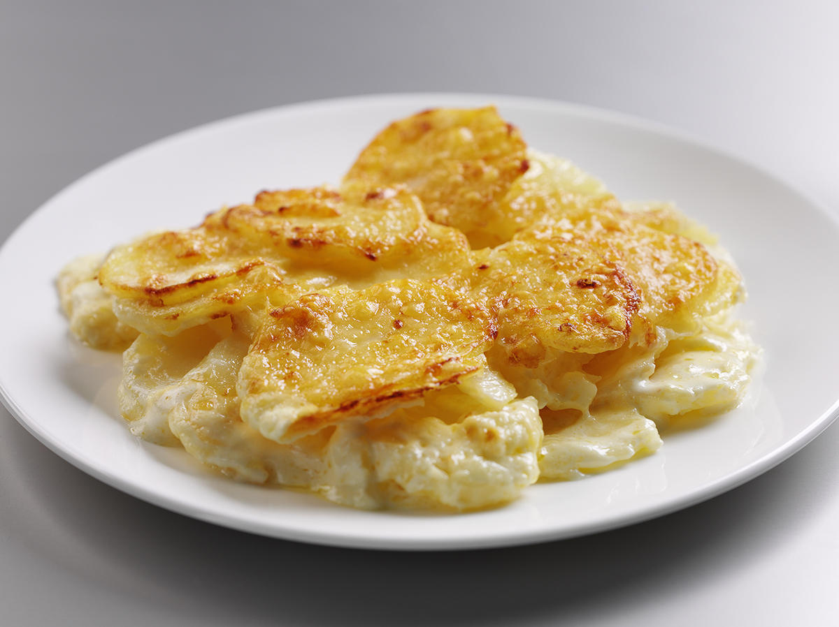
200ml double cream

100ml milk

1 garlic glove

50g gruyere cheese

Pepper for seasoning

Butter for greasing dish

Equipment

Vegetable knife, chopping board, large bowl, garlic crusher, large saucepan, oven-proof dish, grater.

Method
- Preheat the oven to 180°C.
- Thinly slice potatoes and place the slices in a bowl of cold water to prevent them from browning.
- Refresh by rinsing in cold water and pat dry with kitchen paper.
- Peel and crush the garlic.
- Place the cream, milk and crushed garlic in a large saucepan and bring to a simmer.
- Add the potatoes and simmer for 10 minutes until just tender and season well.
- Transfer to a buttered dish.
- Grate the cheese and sprinkle over the potatoes.
- Bake for 25 minutes or until golden. If desired, increase the oven temperature during the last 5-10 minutes of cooking to brown.

Top tips
- Try a different variety of cheeses for the topping, e.g. Emmental, Double Gloucester or Red Leicester.

Food skills
- Weigh.
- Measure.
- Slice.
- Peel.
- Crush.
- Simmer.
- Grate.
- Bake.

