Fondant potatoes
Complexity: low-medium

Ingredients

Smooth potatoes such as Desiree

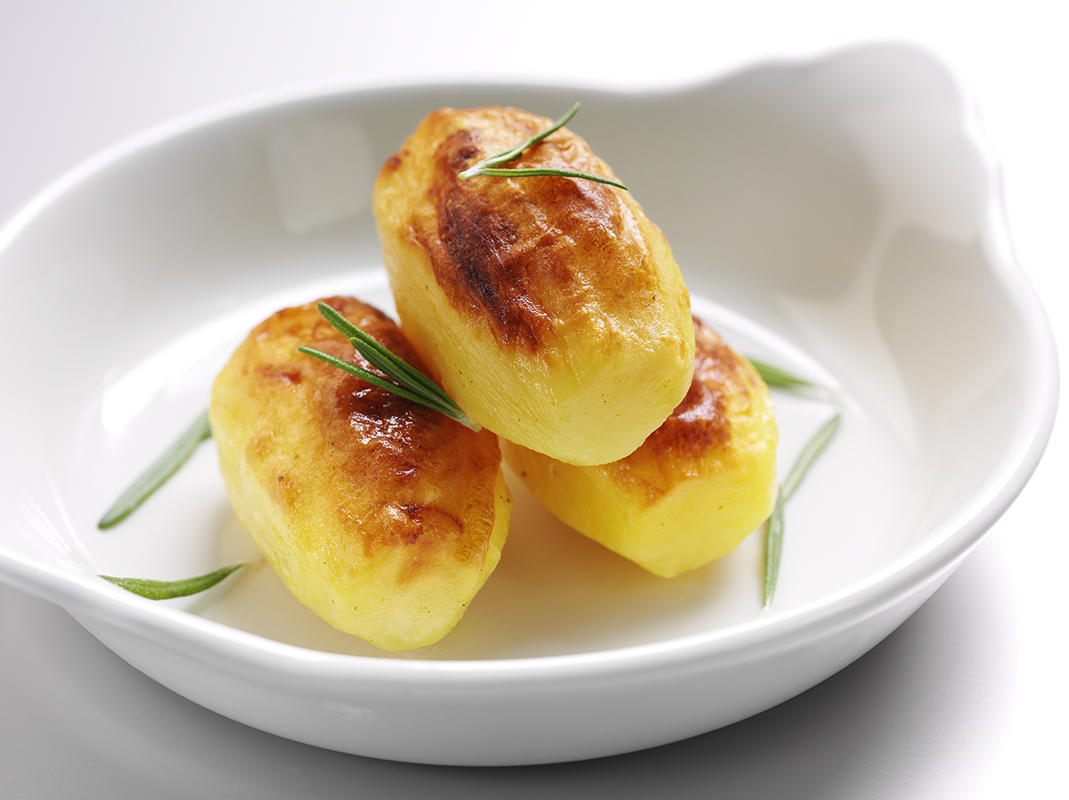
Spread, butter or oil

Chicken or vegetable stock

Pepper for seasoning

Equipment
Peeler, vegetable knife, chopping board, small saucepan, oven-proof pan or dish.

Method
- Preheat the oven to 230°C.
- Choose small or medium, even sized potatoes.
- Wash, peel and rewash the potatoes.
- Turn into 8-sided barrel shapes, about 5cm long and 2.5cm across in the centre, deducing to 1.5cm at each end.
- Prepare enough barrels for 2-3 per person.
- Gently melt the spread or butter in a saucepan or the microwave.
- Brush potatoes with melted spread/butter or oil and place in a pan suitable for the oven.
- Half cover with stock and season with pepper.
- Cook in a hot oven for about 1 hour, brushing the potatoes frequently with melted spread/butter or oil.
- When cooked the stock should be completely absorbed by the potatoes.
- Brush with melted spread/butter or oil.

Top tips
- Serve lightly sprinkled with thyme, rosemary, oregano, or grated cheese.

Food skills
- Peel.
- Cut.
- Melt.
- Glaze.
- Bake.

